Lab 9: Perform Footprinting using Various Footprinting Tools

**Lab Scenario**

The information gathered in the previous steps may not be sufficient to reveal the potential vulnerabilities of the target. There could be more information available that could help in finding loopholes in the target. As an ethical hacker, you should look for as much information as possible about the target using various tools. This lab activity will demonstrate what other information you can extract from the target using various footprinting tools.

**Lab Objectives**

* Footprinting a target using Recon-ng
* Footprinting a target using Maltego
* Footprinting a target using OSRFramework
* Footprinting a target using BillCipher
* Footprinting a target using OSINT Framework

**Overview of Footprinting Tools**

Footprinting tools are used to collect basic information about the target systems in order to exploit them. Information collected by the footprinting tools contains the target’s IP location information, routing information, business information, address, phone number and social security number, details about the source of an email and a file, DNS information, domain information, etc.

Task 1: Footprinting a Target using Recon-ng

Recon-ng is a web reconnaissance framework with independent modules and database interaction that provides an environment in which open-source web-based reconnaissance can be conducted. Here, we will use Recon-ng to perform network reconnaissance, gather personnel information, and gather target information from social networking sites.

The results obtained might differ when you perform this lab task.

1. Click [Parrot Security](https://labclient.labondemand.com/Instructions/b16bedc2-7151-47a3-9211-5daccdd8c426?rc=10) to switch to the **Parrot Security** machine.
2. Click the **MATE Terminal** icon at the top-left corner of the **Desktop** window to open a **Terminal** window.



1. A **Parrot Terminal** window appears. In the terminal window, type **sudo su** and press **Enter** to run the programs as a root user.
2. In the **[sudo] password for attacker** field, type **toor** as a password and press **Enter**.

The password that you type will not be visible.

1. Now, type **cd** and press **Enter** to jump to the root directory.
2. In the **Terminal** window, type the command **recon-ng** and press **Enter** to launch the application.

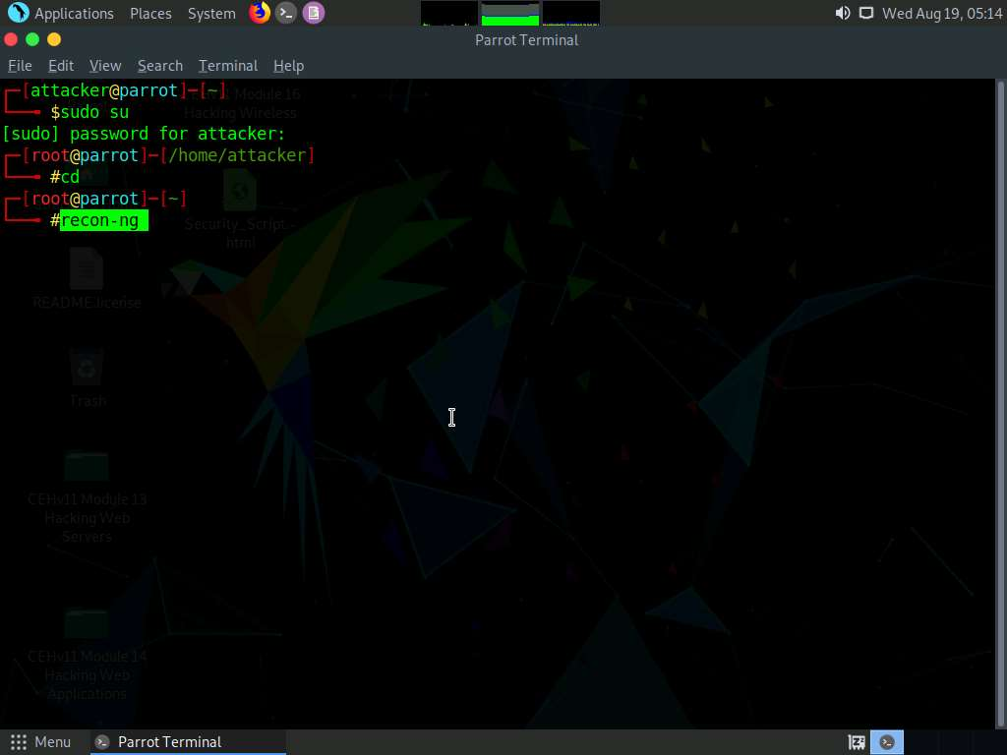

1. Type **help** and press **Enter** to view all the commands that allow you to add/delete records to a database, query a database, etc.

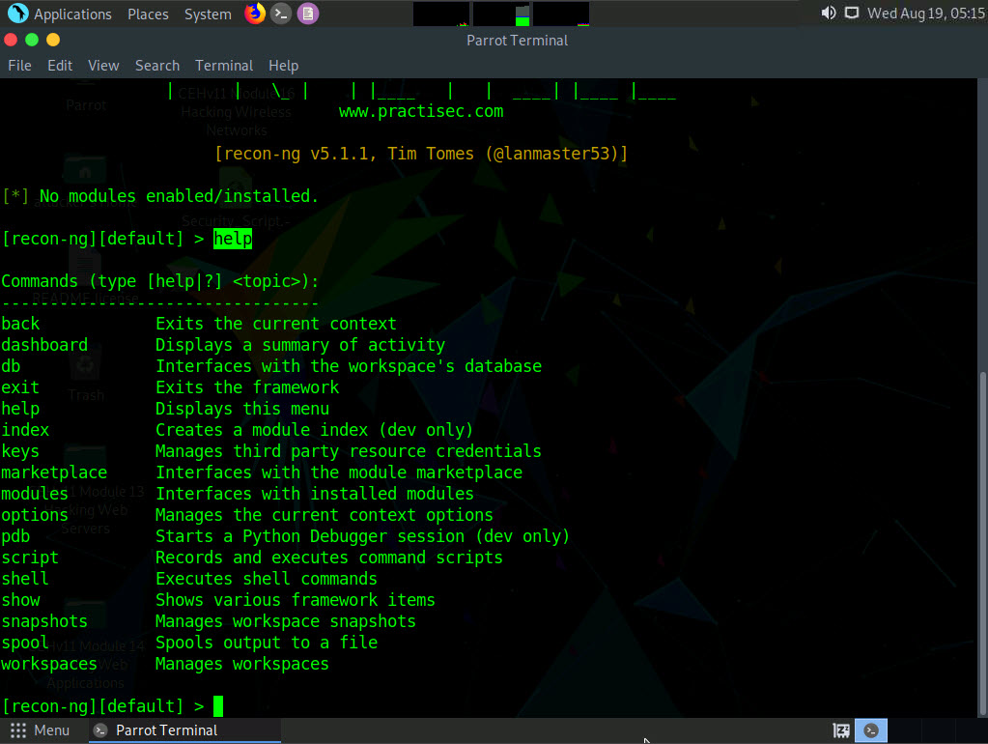

1. Type **marketplace install all** and press **Enter** to install all the modules available in recon-ng.

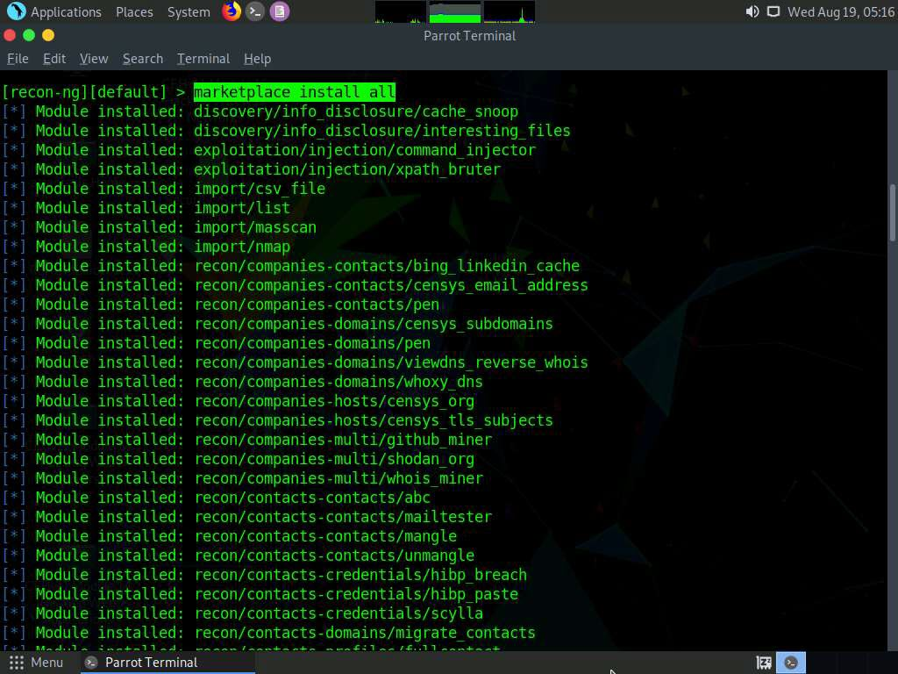

1. After the installation of modules, type the **modules search** command and press **Enter**. This displays all the modules available in recon-ng.

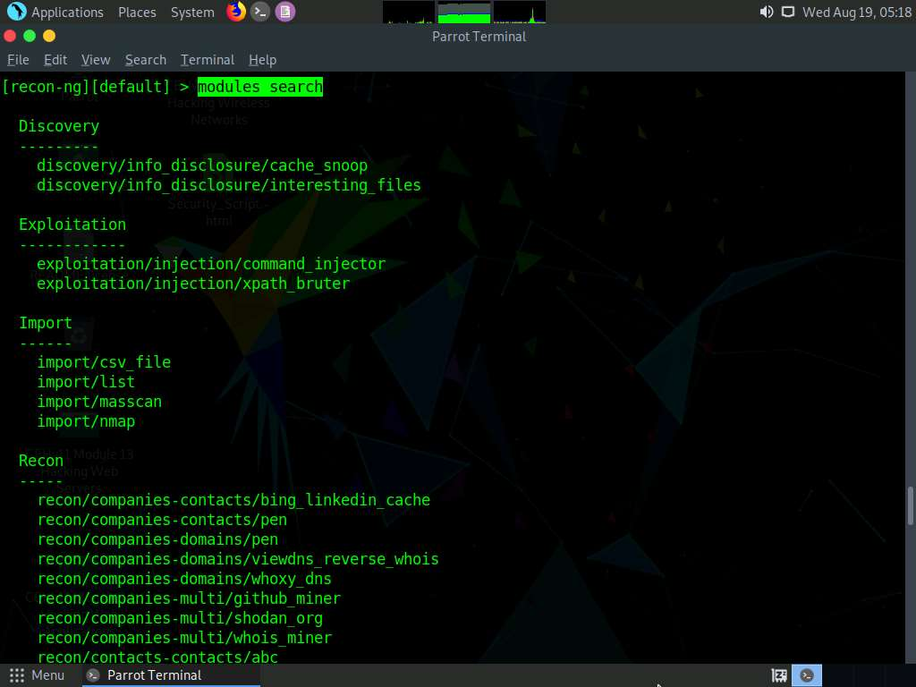

1. You will be able to perform network discovery, exploitation, reconnaissance, etc. by loading the required modules.
2. Type the **workspaces** command and press **Enter**. This displays the commands related to the workspaces.

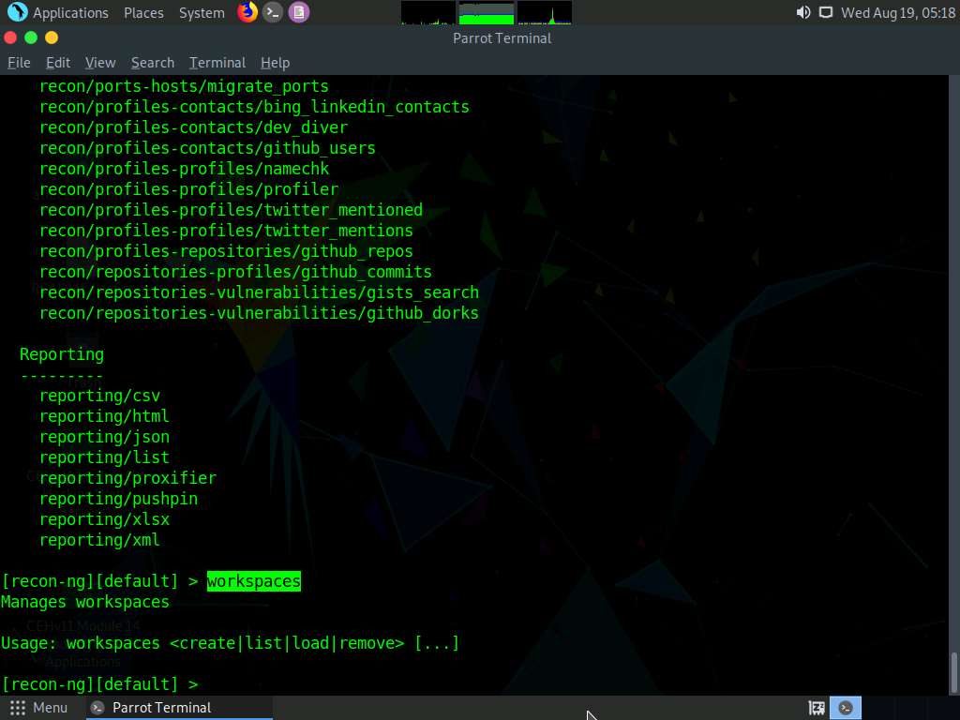

1. Create a workspace in which to perform network reconnaissance. In this task, we shall be creating a workspace named **CEH**.
2. To create the workspace, type the command **workspaces create CEH** and press **Enter**. This creates a workspace named CEH.

You can alternatively issue the command workspaces select CEH to create a workspace named CEH. Ignore the errors while running the commands

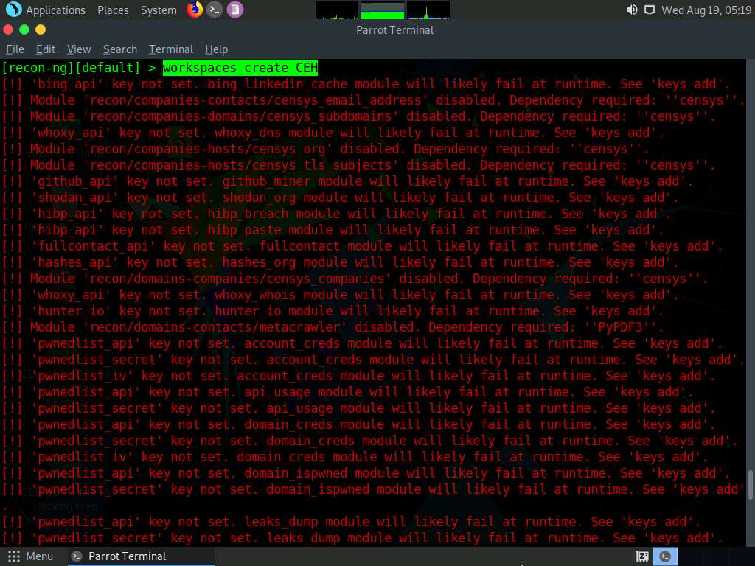

1. Enter **workspaces list**. This displays a list of workspaces (along with the workspace added in the previous step) that are present within the workspaces databases.

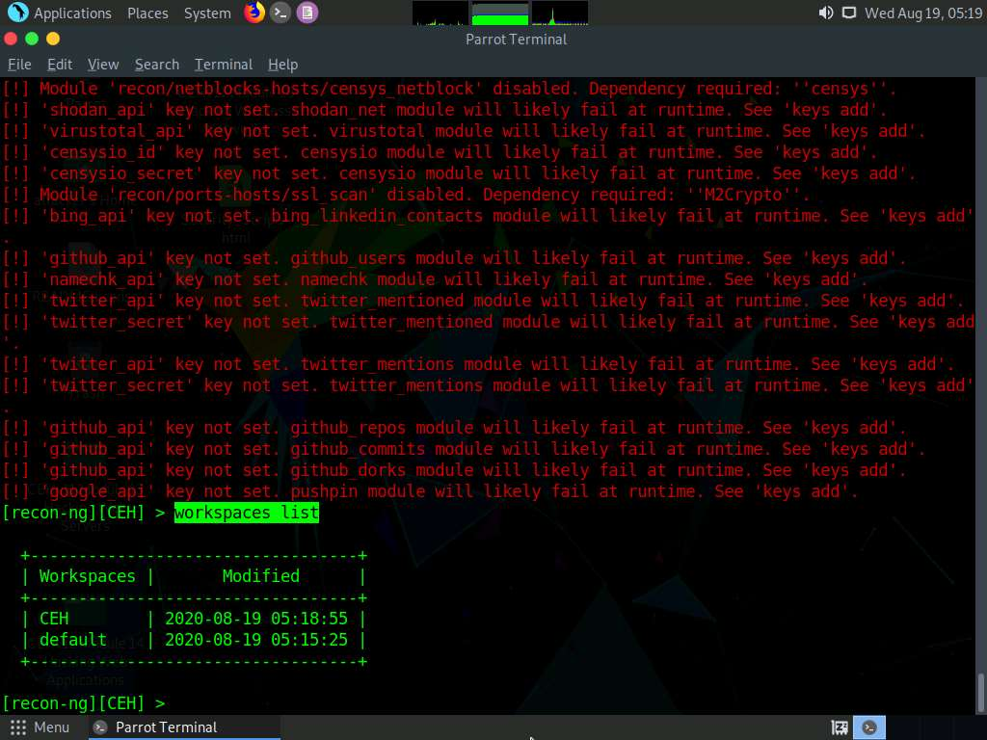

1. Add a domain in which you want to perform network reconnaissance.
2. Type the command **db insert domains** and press **Enter**.
3. In the **domain (TEXT)** option type **certifiedhacker.com** and press **Enter**. In the **notes (TEXT)** option press **Enter**. This adds certifiedhacker.com to the present workspace.
4. You can view the added domain by issuing the **show domains** command, as shown in the screenshot.

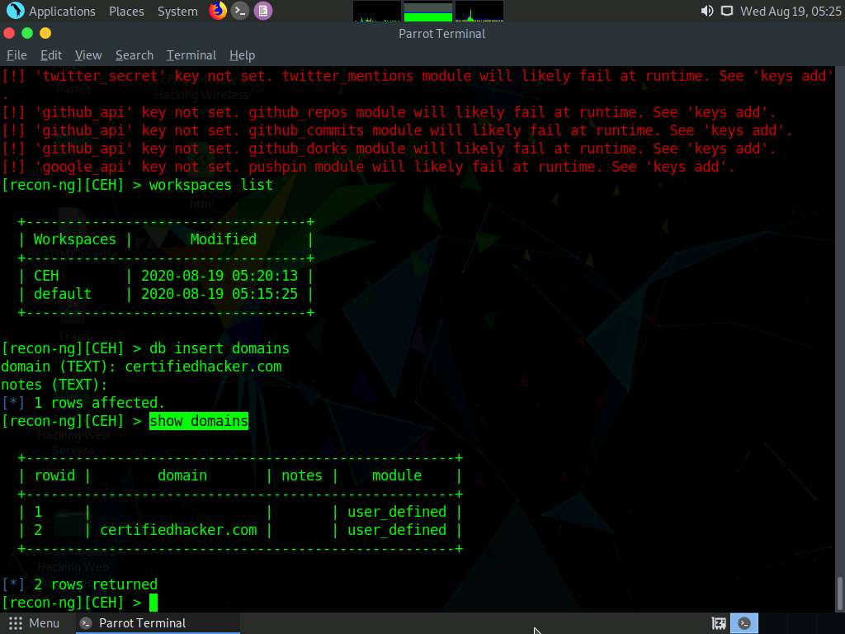

1. Harvest the hosts-related information associated with **certifiedhacker.com** by loading network reconnaissance modules such as brute_hosts, Netcraft, and Bing.
2. Type **modules load brute** and press **Enter** to view all the modules related to brute forcing. In this task, we will be using the **recon/domains-hosts/brute_hosts** module to harvest hosts.

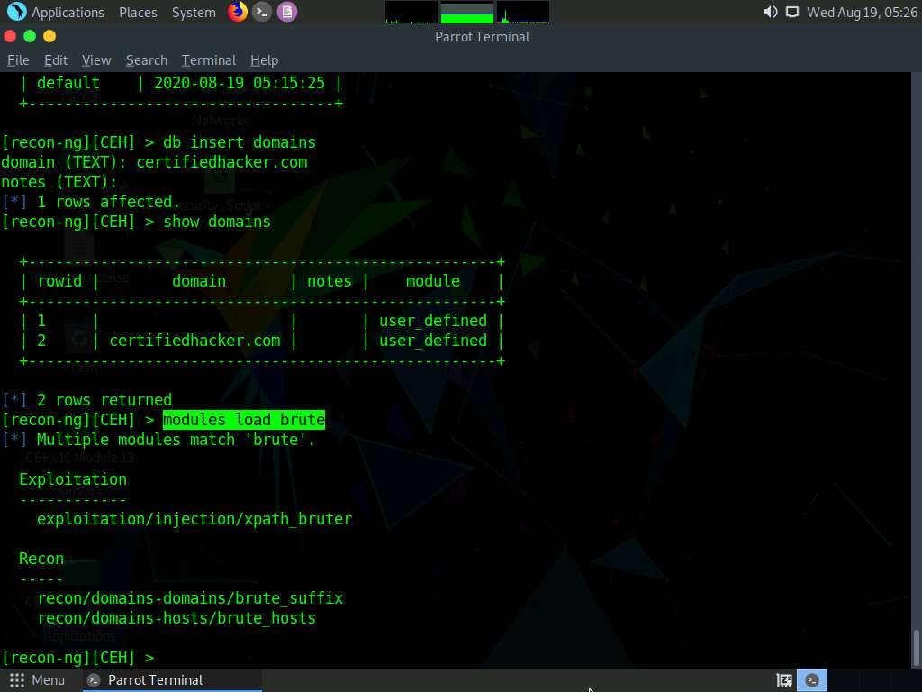

1. To load the **recon/domains-hosts/brute_hosts** module, type the **modules load recon/domains-hosts/brute_hosts** command and press **Enter**.

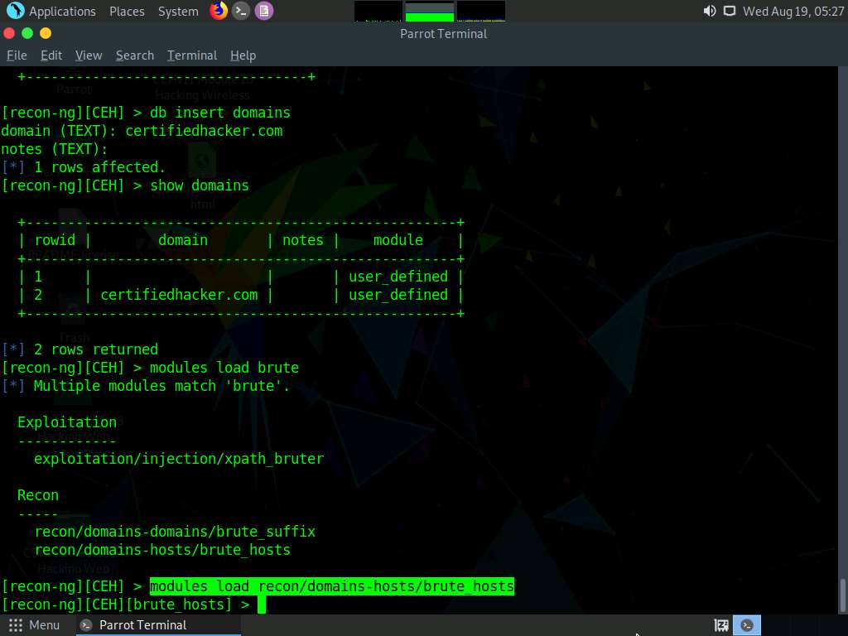

1. Type **run** and press **Enter**. This begins to harvest the hosts, as shown in the screenshot.

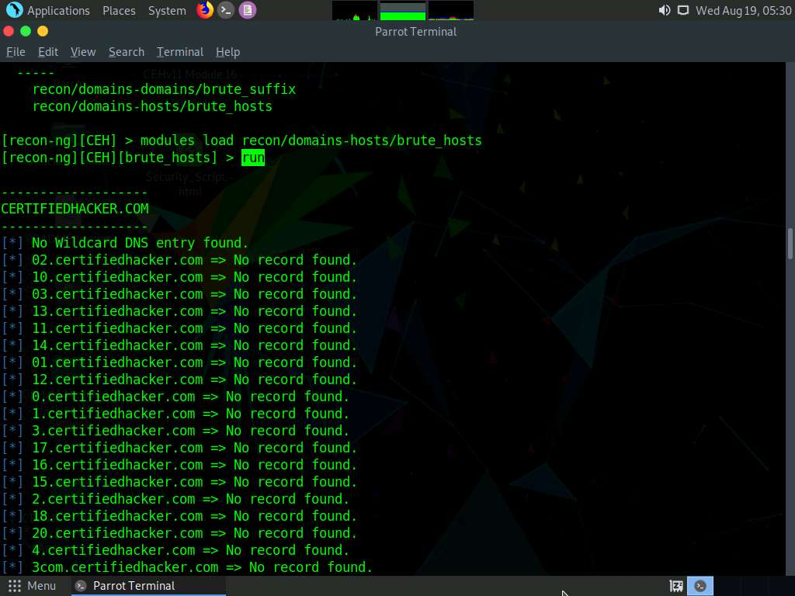

1. Observe that hosts have been added by running the **recon/domains-hosts/brute_hosts** module.

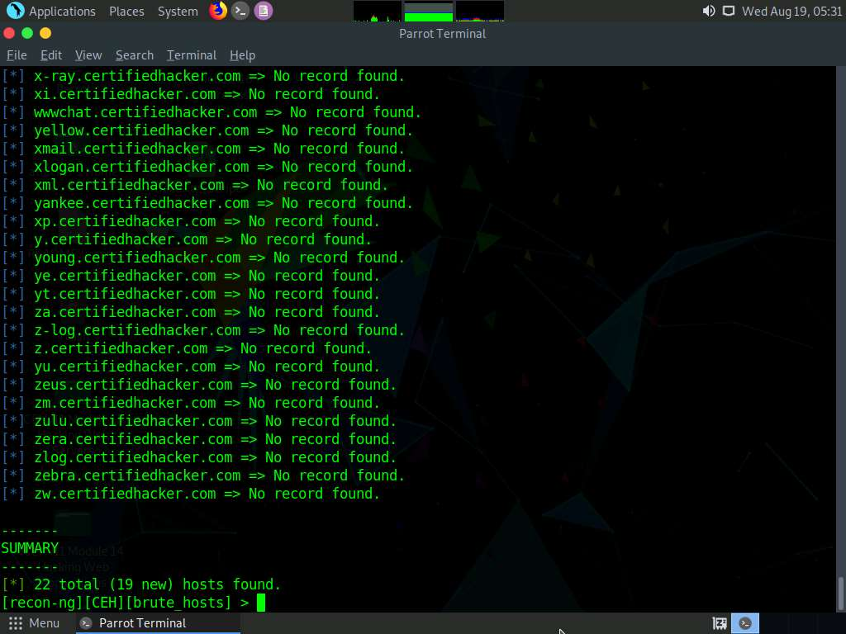

1. You have now harvested the hosts related to certifiedhacker.com using the brute_hosts module. You can use other modules such as Netcraft and Bing to harvest more hosts.

Use the **back** command to go back to the CEH attributes terminal.

To resolve hosts using the Bing module, use the following commands:

* + **back**
  + **modules load recon/domains-hosts/bing_domain_web**
  + **run**

1. Now, perform a reverse lookup for each IP address (the IP address that is obtained during the reconnaissance process) to resolve to respective hostnames.
2. Type **modules load reverse_resolve** command and press **Enter** to view all the modules associated with the reverse_resolve keyword. In this task, we will be using the **recon/hosts-hosts/reverse_resolve** module.
3. Type the **modules load recon/hosts-hosts/reverse_resolve** command and press **Enter** to load the module.

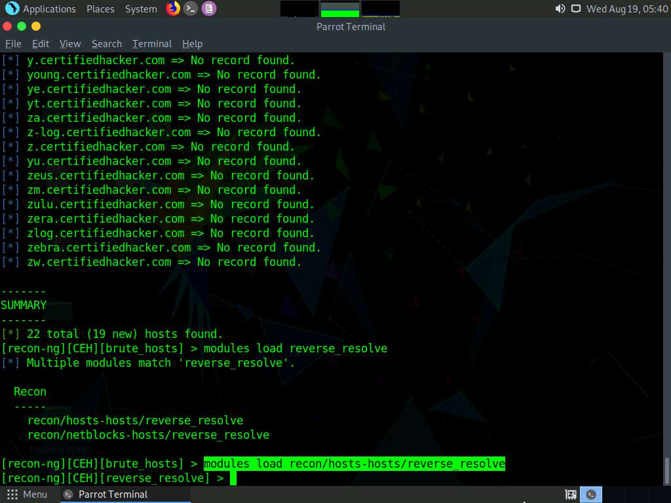

1. Issue the **run** command to begin the reverse lookup.

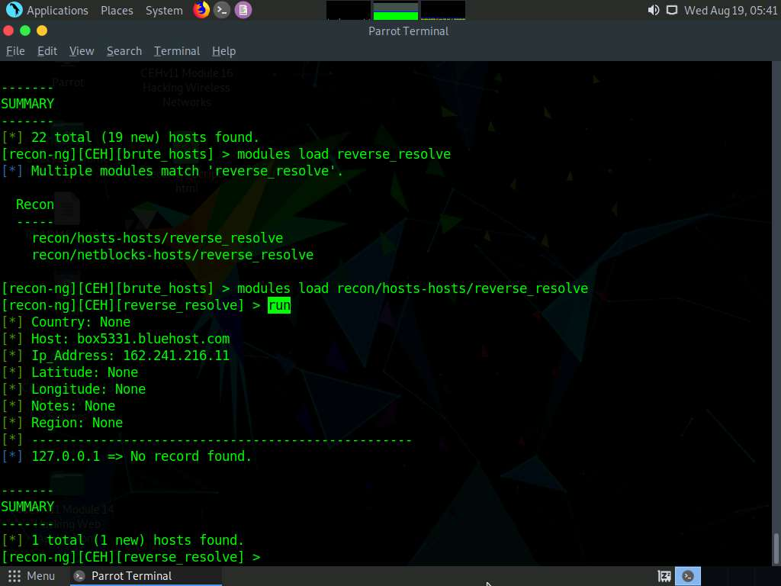

1. Once done with the reverse lookup process, type the **show hosts** command and press **Enter**. This displays all the hosts that are harvested so far, as shown in the screenshot.

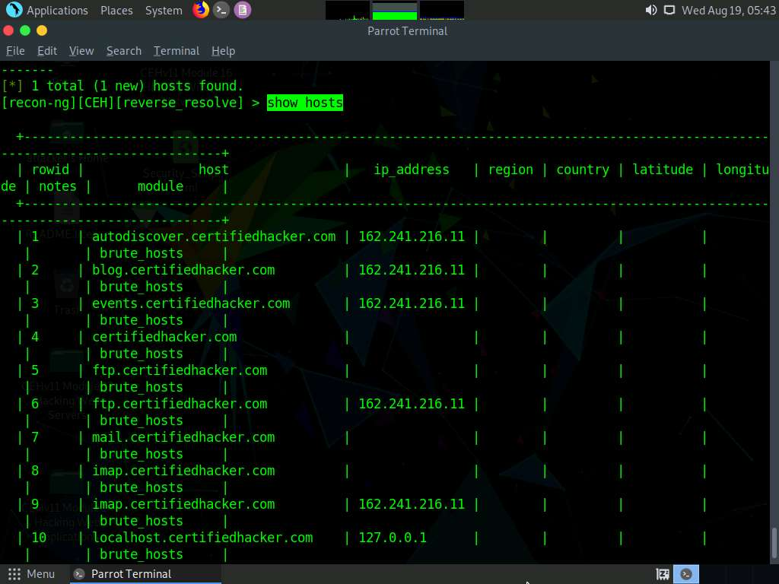

1. Now, type the **back** command and press **Enter** to go back to the CEH attributes terminal.

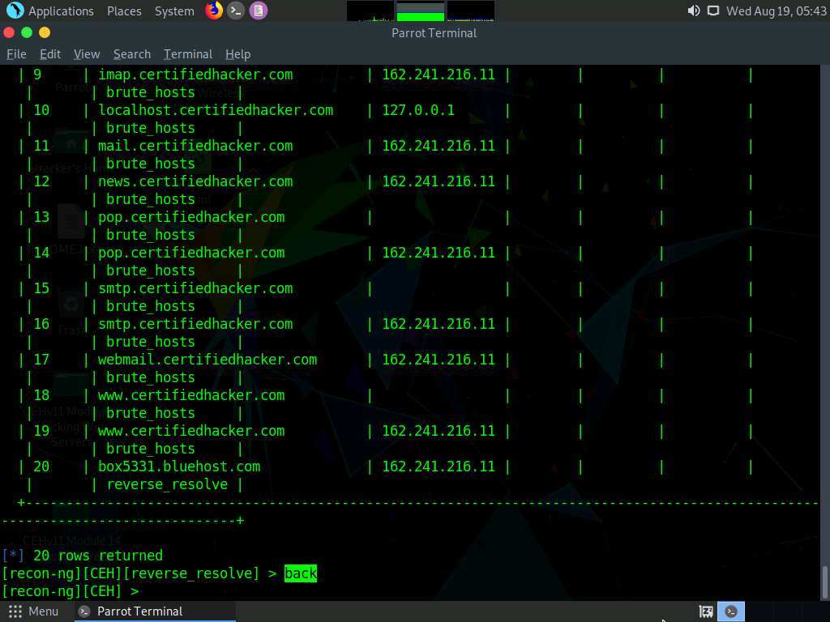

1. Now, that you have harvested several hosts, we will prepare a report containing all the hosts.
2. Type the **modules load reporting** command and press **Enter** to view all the modules associated with the reporting keyword. In this lab, we will save the report in HTML format. So, the module used is **reporting/html**.
3. Type the **modules load reporting/html** command and press **Enter**.
4. Observe that you need to assign values for **CREATOR** and **CUSTOMER** options while the **FILENAME** value is already set, and you may change the value if required.
5. Type:
   * **options set FILENAME /root/Desktop/results.html** and press **Enter**. By issuing this command, you are setting the report name as **results.html** and the path to store the file as **Desktop**.
   * **options set CREATOR [your name]** (here, **Jason**) and press **Enter**.
   * **options set CUSTOMER Certifiedhacker Networks** (since you have performed network reconnaissance on **certifiedhacker.com** domain) and press **Enter**.
6. Type the **run** command and press **Enter** to create a report for all the hosts that have been harvested.

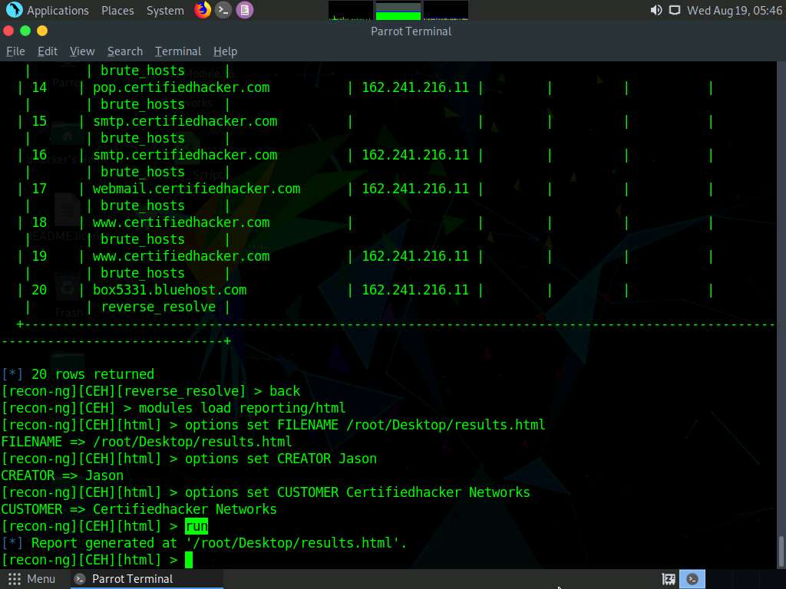

1. The generated report is saved to **/root/Desktop/**.
2. Click **Places** from the top-section of the **Desktop** and click **Home Folder** from the drop-down options.
3. The **attacker** window appears, click **File System** from the left-pane and then double-click **root** from the right-pane.

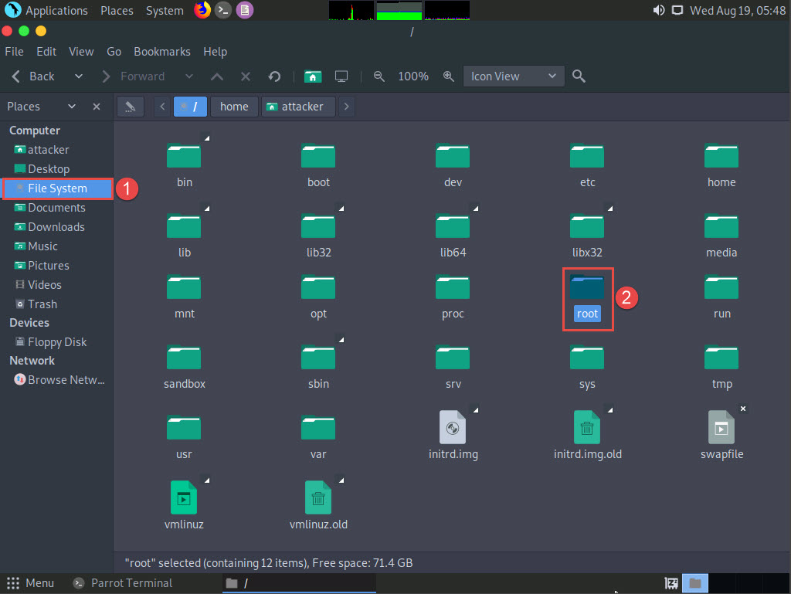

1. The **root** window appears, double-click **Desktop** folder.

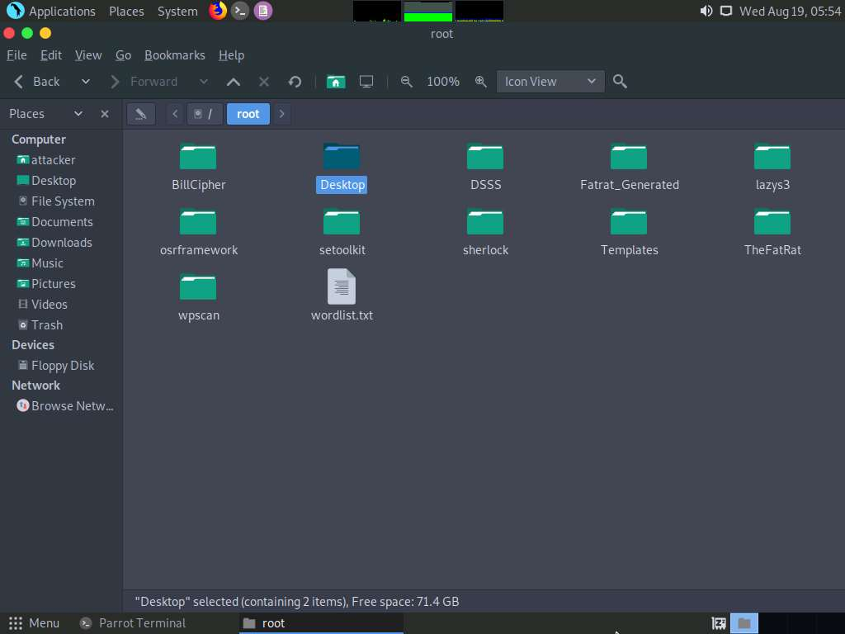

1. **Desktop** window appears, right-click on the **results.html** file, click on **Open With**, and select the **Firefox** browser from the available options.

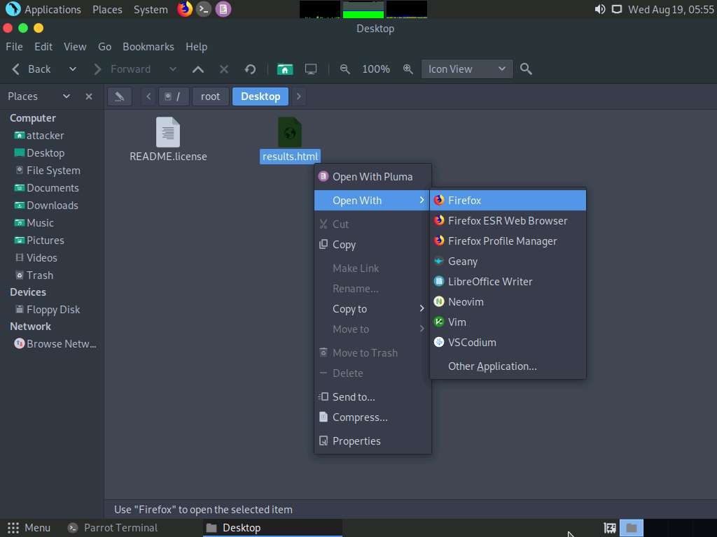

1. The generated report appears in the **Firefox** browser, displaying the summary of the harvested hosts.

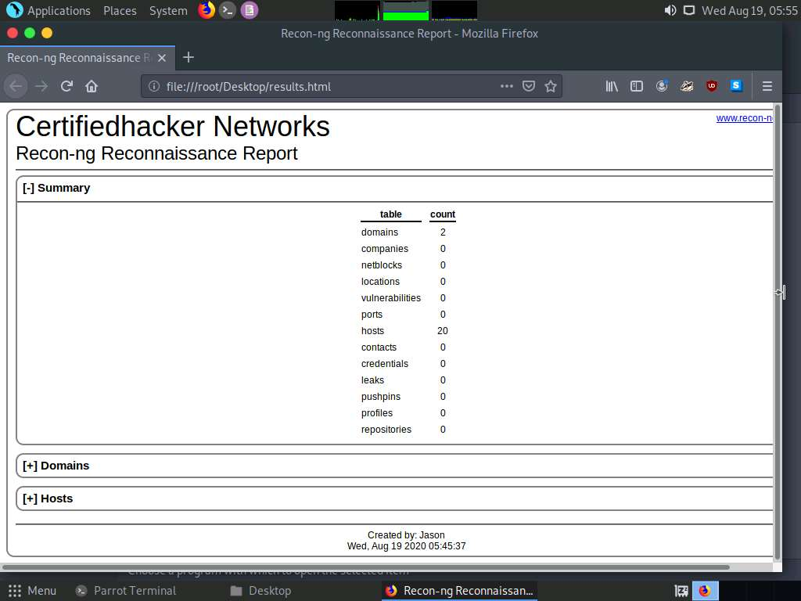

1. You can expand the **Hosts** node to view all the harvested hosts, as shown in the screenshot.

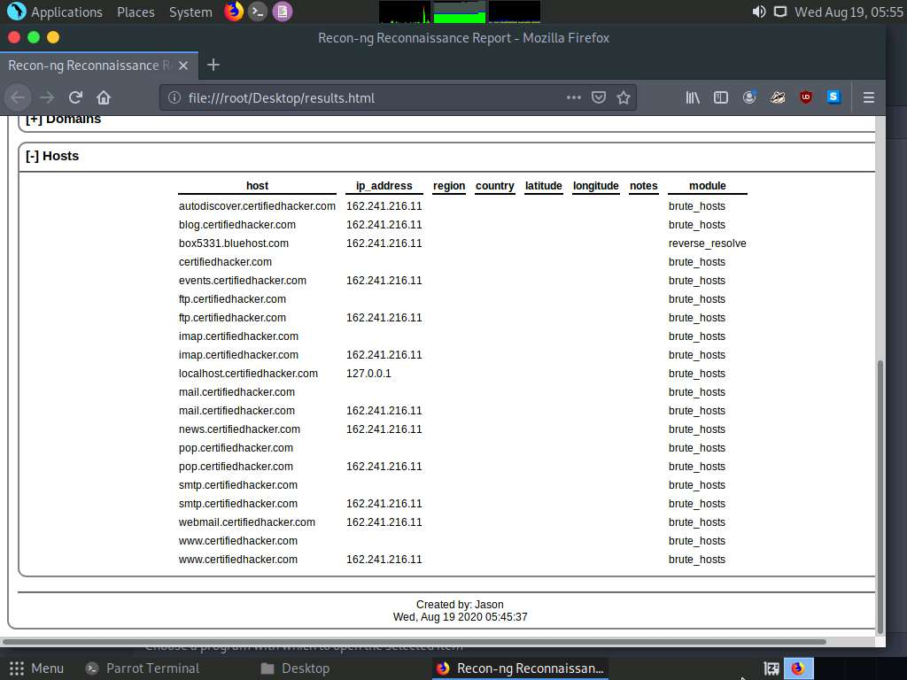

1. Close all open windows.
2. Until now, we have used the Recon-ng tool to perform network reconnaissance on a target domain
3. Now, we will use Recon-ng to gather personnel information.
4. Open a new **Parrot Terminal** window, In the terminal window, type **sudo su** and press **Enter** to run the programs as a root user.
5. In the **[sudo] password for attacker** field, type **toor** as a password and press **Enter**.

The password that you type will not be visible.

1. Now, type **cd** and press **Enter** to jump to the root directory.
2. Type **recon-ng**, and press **Enter**.

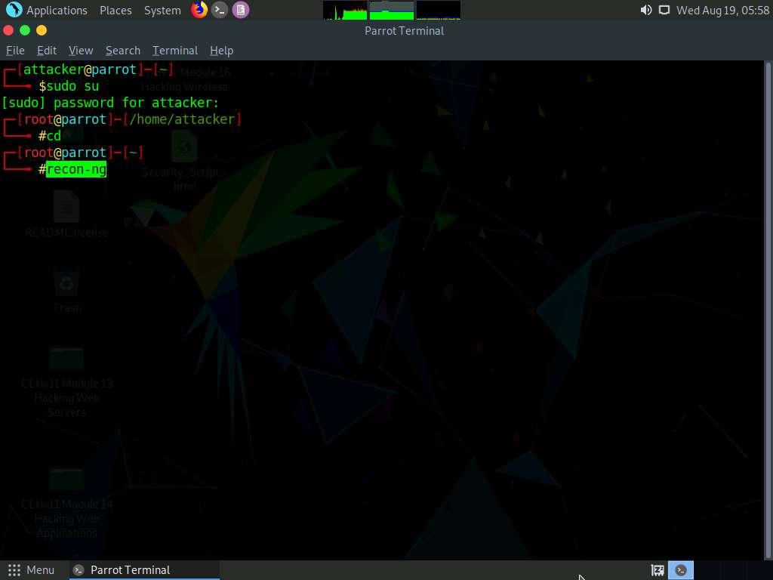

1. Add a workspace by issuing the command **workspaces create reconnaissance** and press **Enter**. This creates a workspace named reconnaissance.

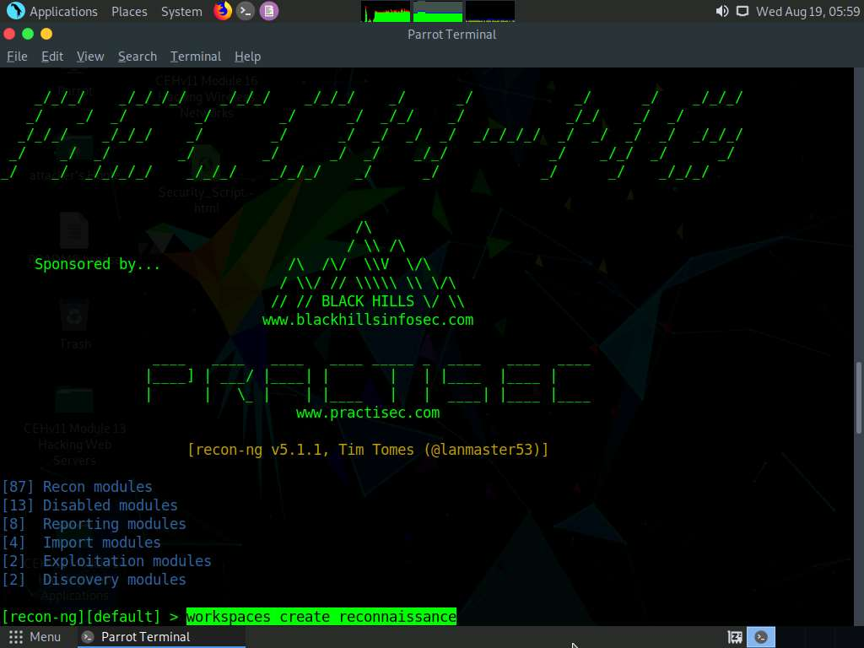

1. Set a domain and perform footprinting on it to extract contacts available in the domain.
2. Type **modules load recon/domains-contacts/whois_pocs** and press **Enter**. This module uses the ARIN Whois RWS to harvest POC data from Whois queries for the given domain.
3. Type the **info** **command** and press **Enter** to view the options required to run this module.
4. Type **options set SOURCE facebook.com** and press **Enter** to add facebook.com as a target domain.

Here, we are using facebook.com as a target domain to gather contact details.

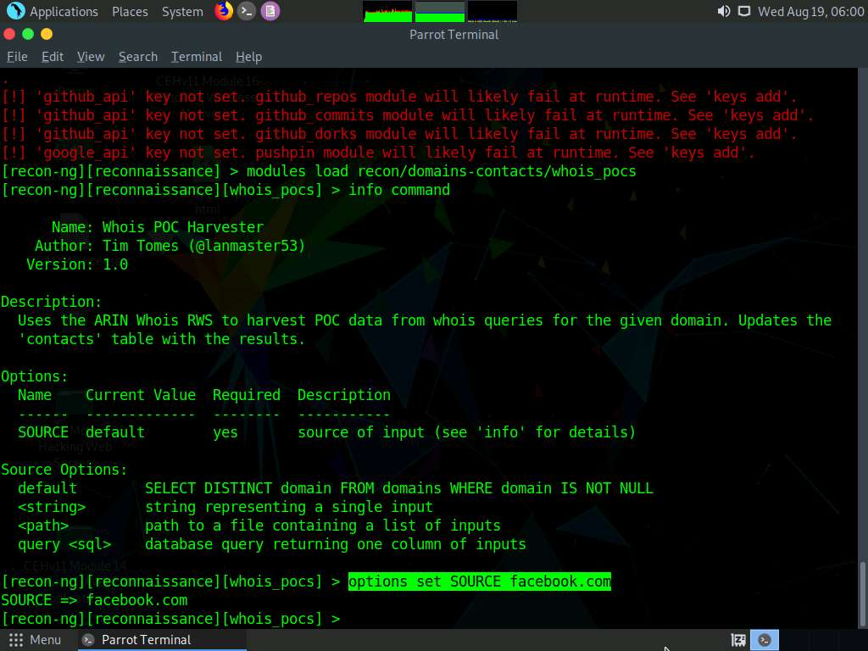

1. Type the **run** command and press **Enter**. The **recon/domains-contacts/whois_pocs** module extracts the contacts associated with the domain and displays them, as shown in the screenshot

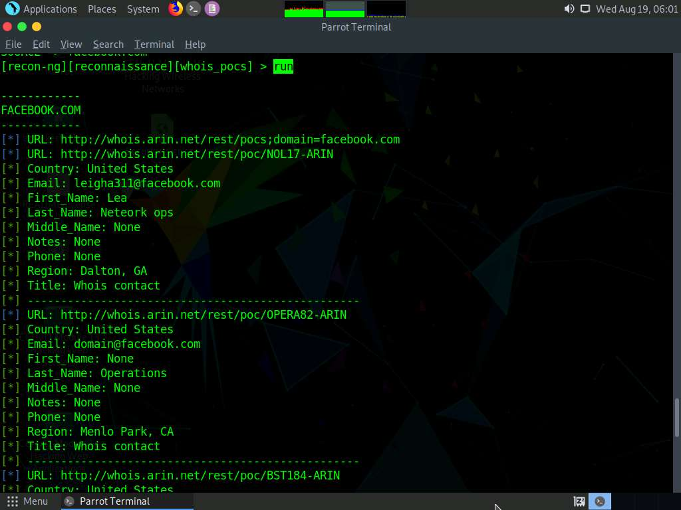

1. Type **back** and press **Enter** to go back to the workspaces (**reconnaissance**) terminal.

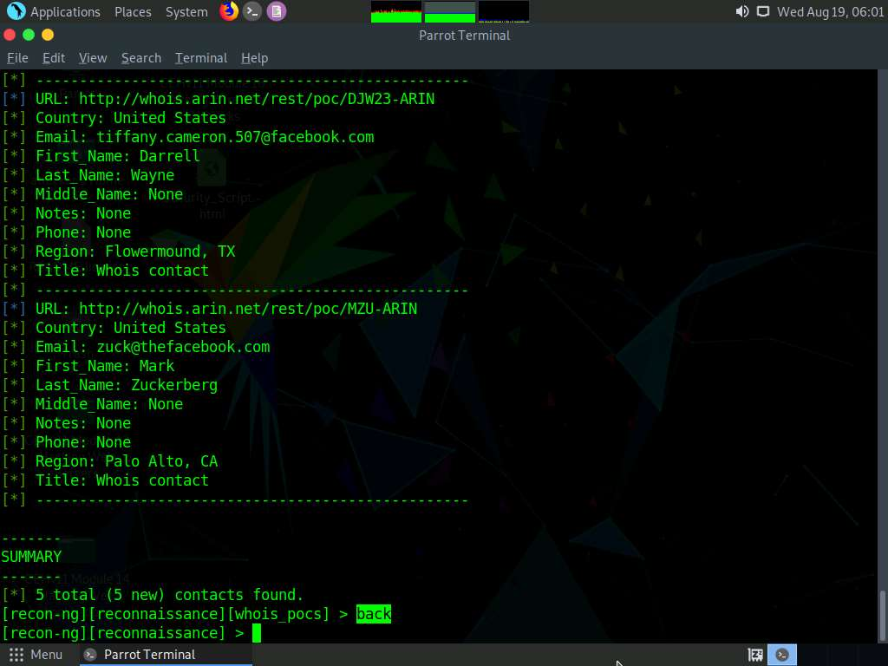

1. Until now, we have obtained contacts related to the domains. Note down these contacts’ names.
2. Now, we will validate the existence of names (usernames) on specific websites.
3. The **recon/profiles-profiles/namechk** module validates the username existence of a specified contact. The contact we will use in this lab is **Mark Zuckerberg**.
4. Type the **modules load recon/profiles-profiles/namechk** command and press **Enter** to load this module.
5. Type **options set SOURCE MarkZuckerberg** and press **Enter**. This command sets MarkZuckerberg as the source for which you want to find the user existence on specific websites.
6. Type **run** and press **Enter**. This begins the search for the keyword MarkZuckerberg on various websites.
7. Recon-ng begins to search the Internet for the presence of the username on websites and, if found, it returns the result stating “**User Exists!**”. Here, no results are obtained.

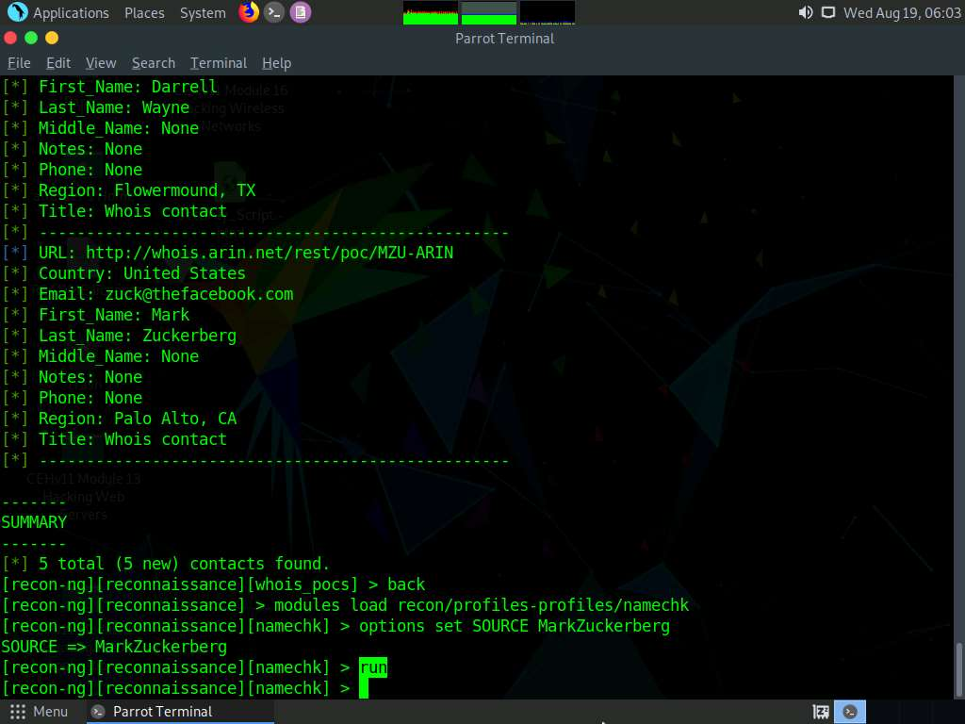

1. Type the **back** command and press **Enter** to go back to the workspaces (reconnaissance) terminal.
2. To find the existence of user-profiles on various websites, you need to load the **recon/profiles-profiles/profiler** module.
3. Type the **modules load recon/profiles-profiles/profiler** command and press **Enter**.
4. Type the **options set SOURCE MarkZuckerberg** command and press **Enter**.
5. Type the **run** command and press **Enter**. The recon/profiles-profiles/profiler module searches for this username and returns the URL of the profile (found with the matching username):

Ignore any errors received in the results.

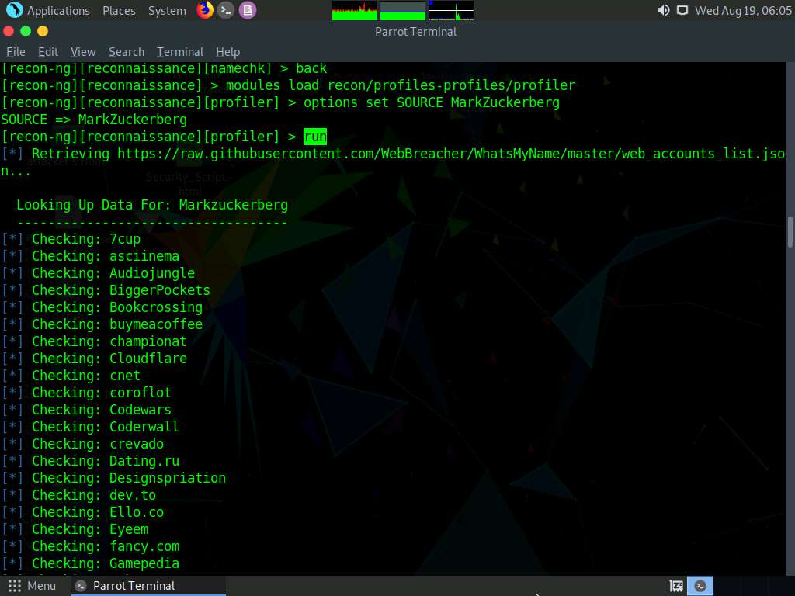

1. Type **back** and press **Enter** to go back to the workspaces terminal.
2. Now that we have verified the user existence and obtained the profile URL, we will prepare a report containing the result.
3. Type the **modules load reporting/html** command and press **Enter**. Assign values for **FILENAME**, **CREATOR**, and **CUSTOMER**.

In this task, we are saving the report in HTML format; therefore, **reporting/html** module is used.

1. Type:
   * **options set FILENAME /root/Desktop/Reconnaissance.html** and press **Enter**. By issuing this command, you are setting the report name as **Reconnaissance.html** and the path to store the file as **Desktop**.
   * **options set CREATOR [your name]** (here, **Jason**) and press **Enter**.
   * **options set CUSTOMER Mark Zuckerberg** (since you have performed information gathering on the name of **Mark Zuckerberg**) and press **Enter**.
2. After entering the above details, type the **run** command and press **Enter** to create a report for all the hosts that have been harvested, as shown in the screenshot.

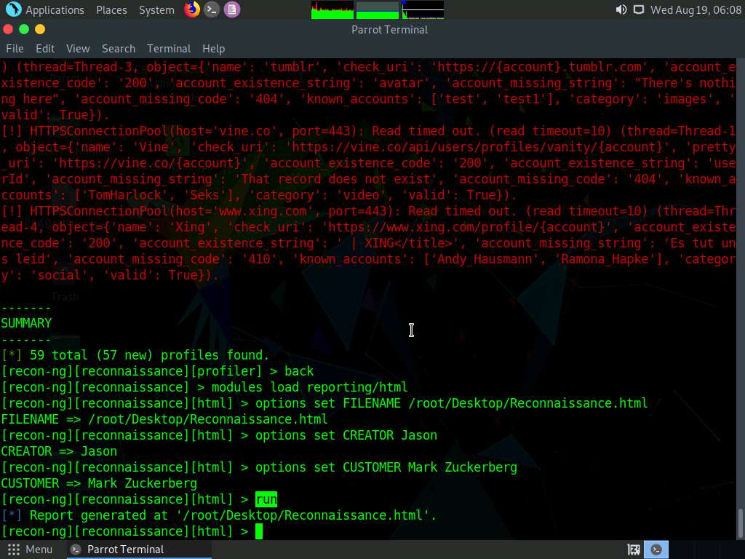

1. The generated report is saved to **/root/Desktop/**.
2. Click **Places** from the top-section of the **Desktop** and click **Home Folder** from the drop-down options.
3. The **attacker** window appears, click **File System** from the left-pane and then double-click **root** from the right-pane.

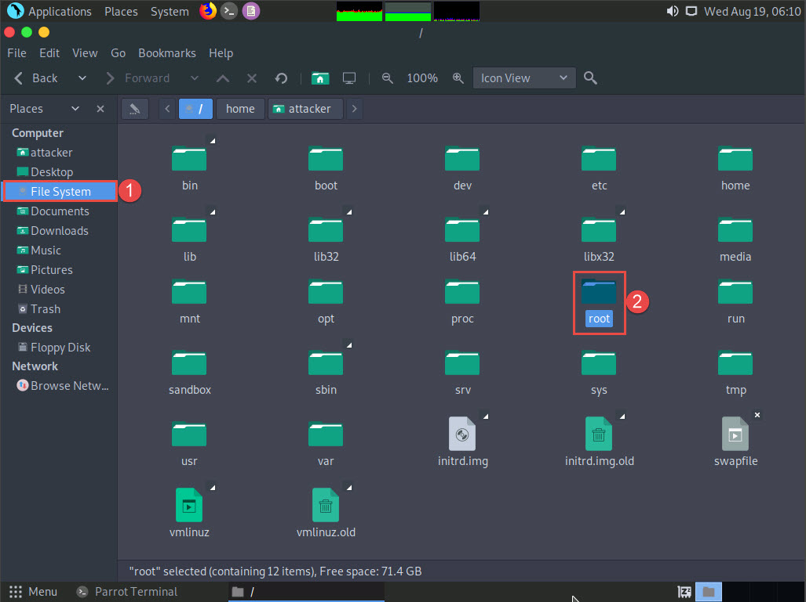

1. The **root** window appears, double-click **Desktop** folder.

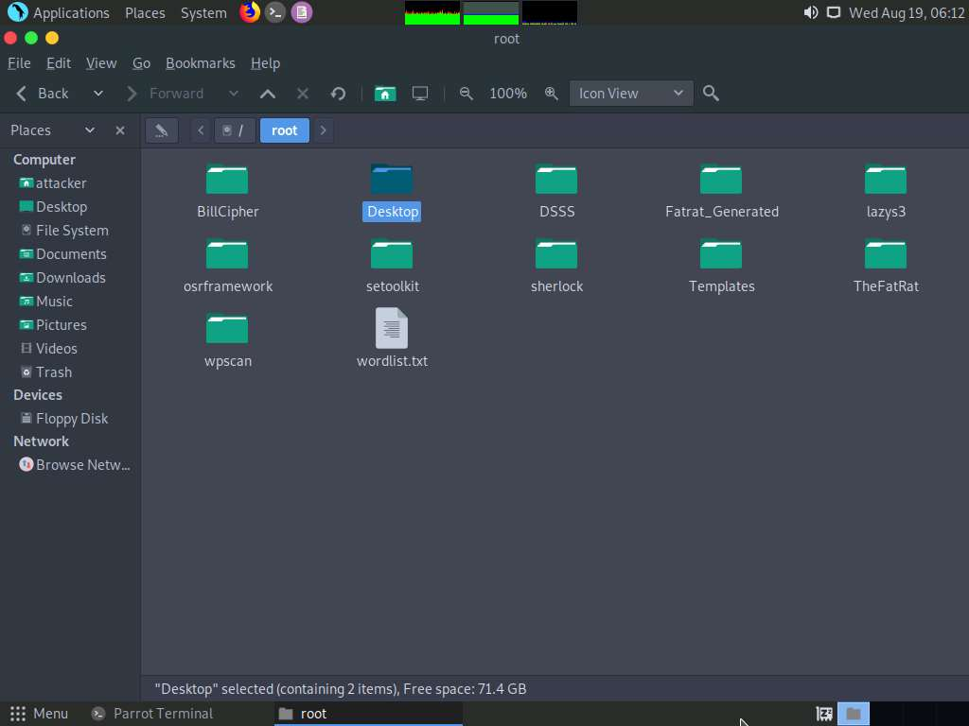

1. **Desktop** window appears, right-click on the **Reconnaissance.html** file, click on **Open With**, and select the **Firefox** browser from the available options.

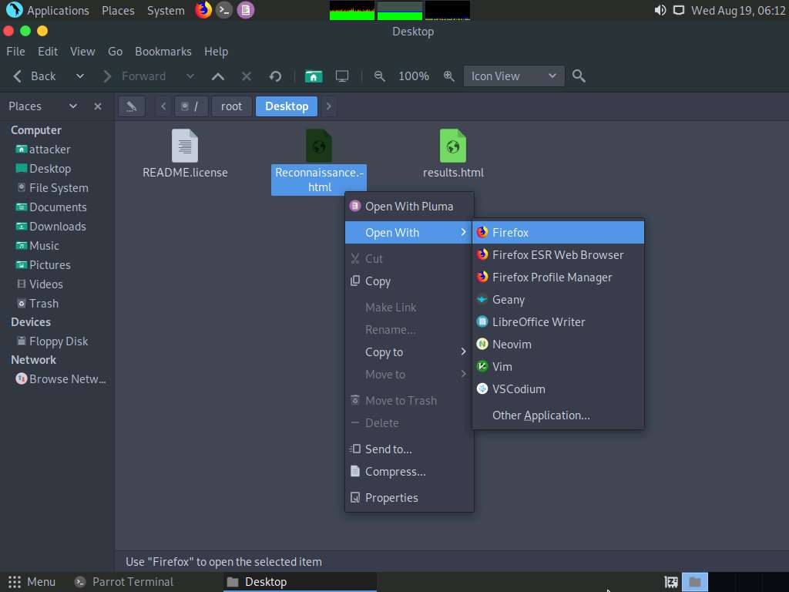

1. The generated report appears in the **Firefox** browser, displaying a summary of the result. You can expand the **Contacts** and **Profiles** nodes to view all the obtained results.

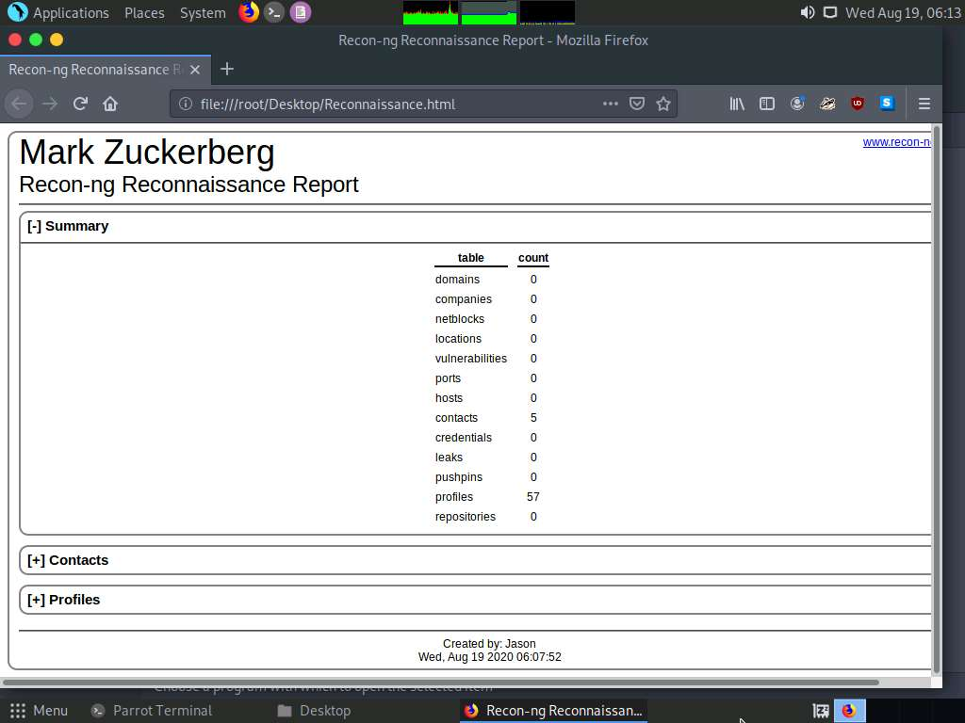

1. You can further expand the **Contacts** and **Profiles** node to view detailed information about the target.

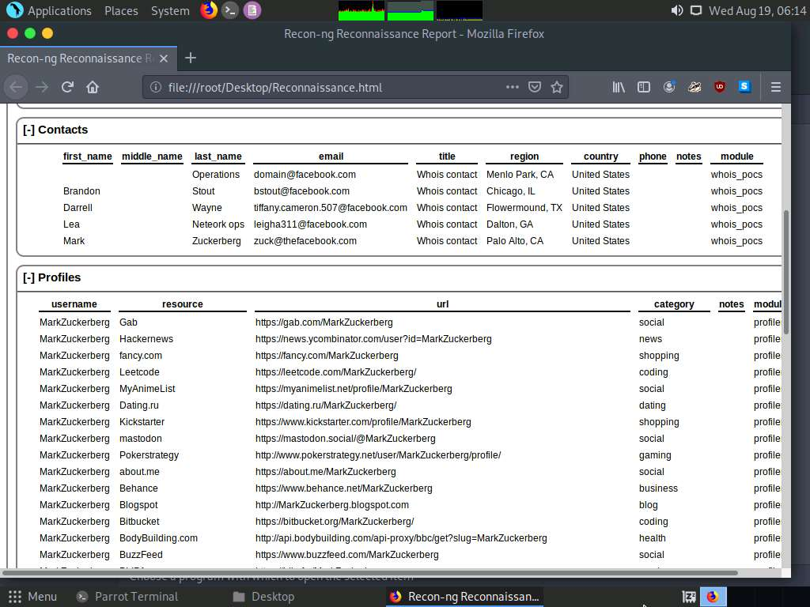

1. We have now gathered information about the employee working in a target organization.
2. This concludes the demonstration of gathering host information of the target domain and gathering personnel information of a target organization.
3. Close all open windows and document all the acquired information.

Task 2: Footprinting a Target using Maltego

Maltego is a footprinting tool used to gather maximum information for the purpose of ethical hacking, computer forensics, and pentesting. It provides a library of transforms to discover data from open sources and visualizes that information in a graph format, suitable for link analysis and data mining. Maltego provides you with a graphical interface that makes seeing these relationships instant and accurate, and even making it possible to see hidden connections.

Here, we will gather a variety of information about the target organization using Maltego.

1. Click [Parrot Security](https://labclient.labondemand.com/Instructions/b16bedc2-7151-47a3-9211-5daccdd8c426?rc=10) to switch to the **Parrot Security** machine, launch **Maltego** by navigating to **Applications** --> **Pentesting** --> **Information Gathering** --> **OSINT Analysis** --> **maltego**, as shown in the screenshot.

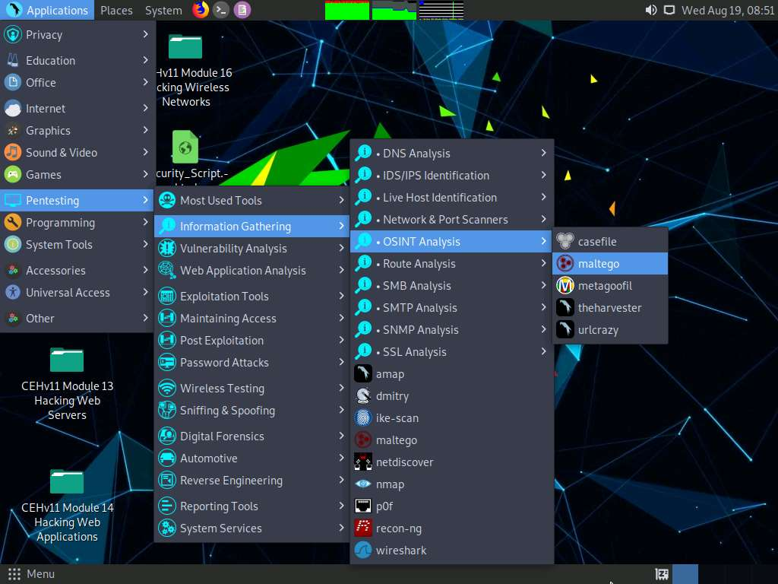

1. A security pop-up appears, enter password as **toor** in the **password** field and click **OK**.

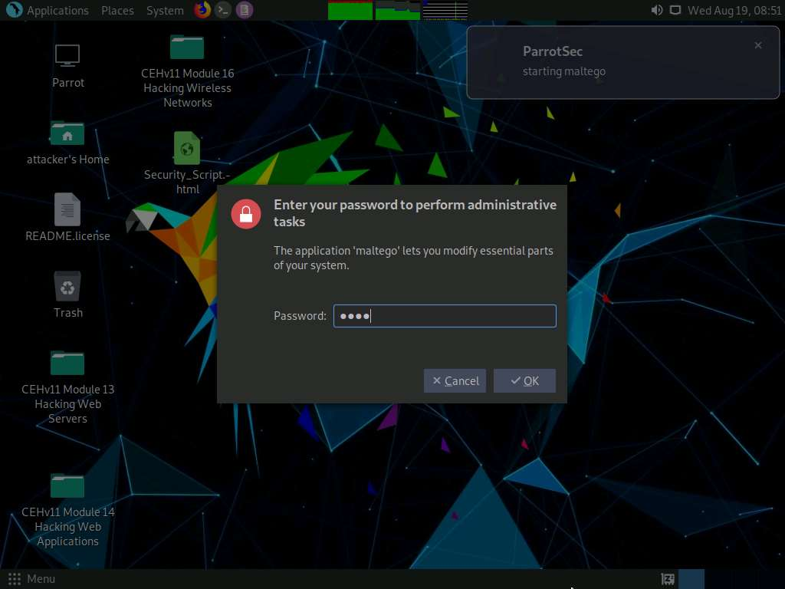

1. A **Product Selection** wizard appears on the Maltego GUI; click **Run** from **Maltego CE (Free)** option.

If the **Memory Settings Optimized** pop-up appears, click **Restart Now**.

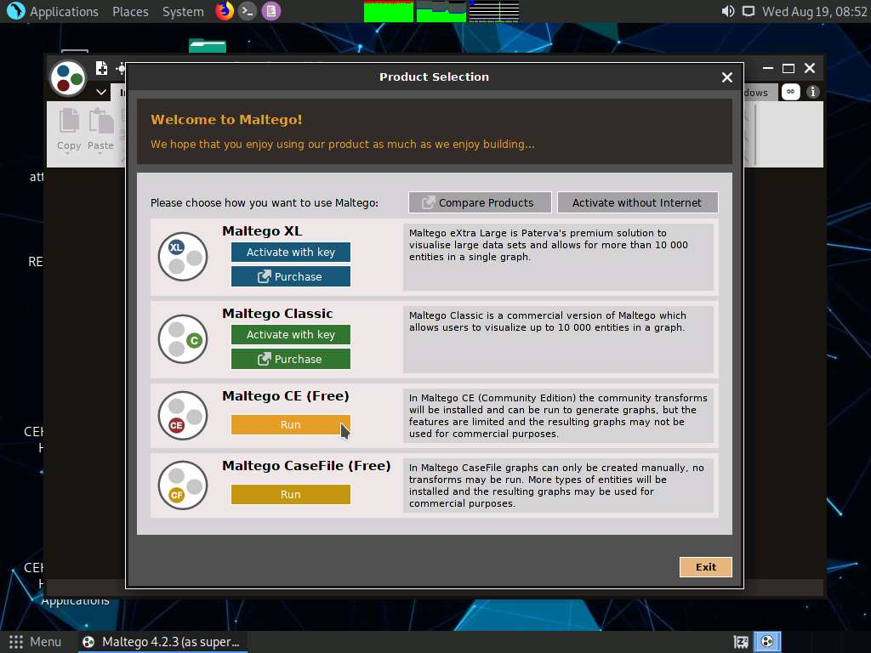

1. As the **Configure Maltego** window appears along with a **LICENSE AGREEMENT** form, check the **Accept** checkbox and click **Next**.
2. You will be redirected to the **Login** section; leave the **Maltego** window as it is and click **Firefox** icon from the top-section of the window to launch the Firefox browser.

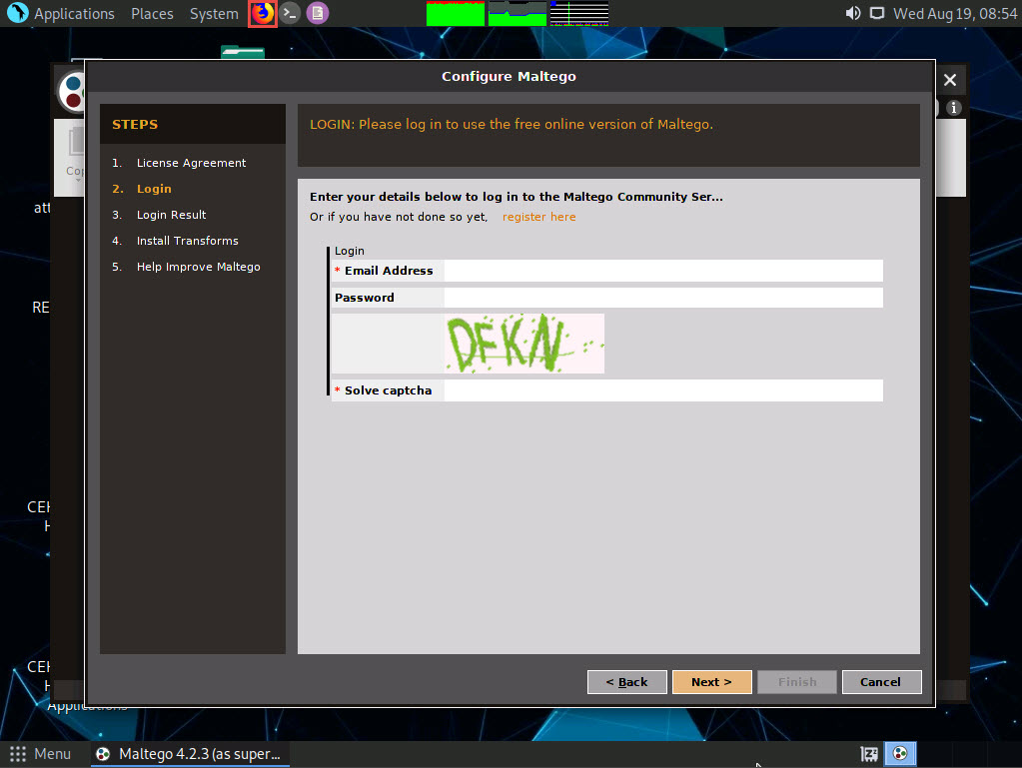

1. The **Firefox** window appears in the address type **https://www.maltego.com/ce-registration** and press **Enter**.
2. A **Register a Maltego CE Account** page appears, enter your details and confirm the captcha, and click **REGISTER** button to register your account and activate it.

If cookie notification appears in the lower section of the browser, click **Accept**.

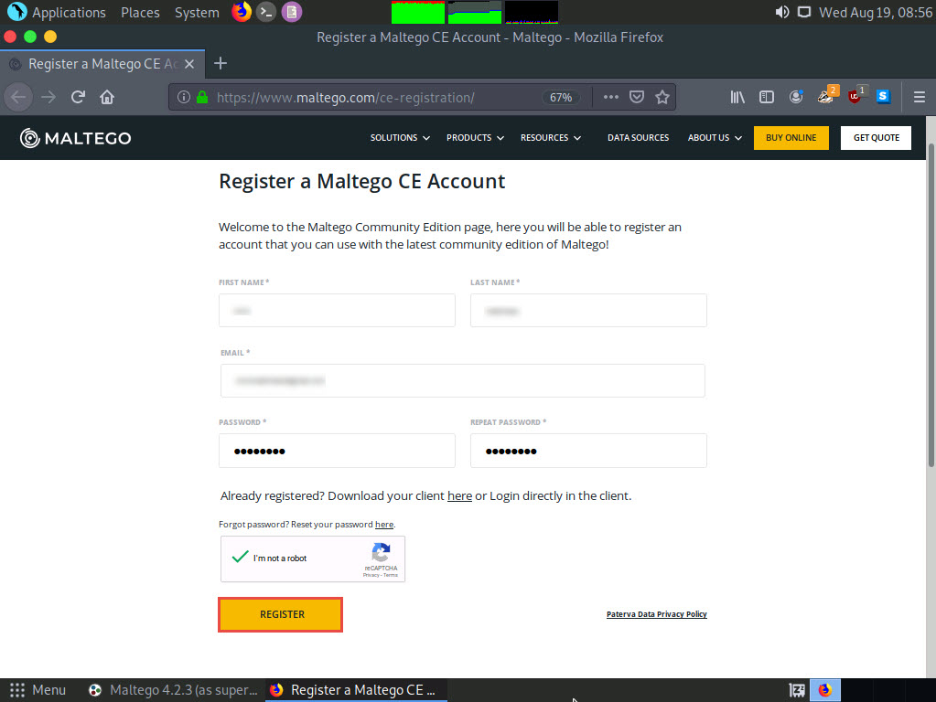

1. **Mail Sent!** notification appears, click **BACK TO HOME** button.

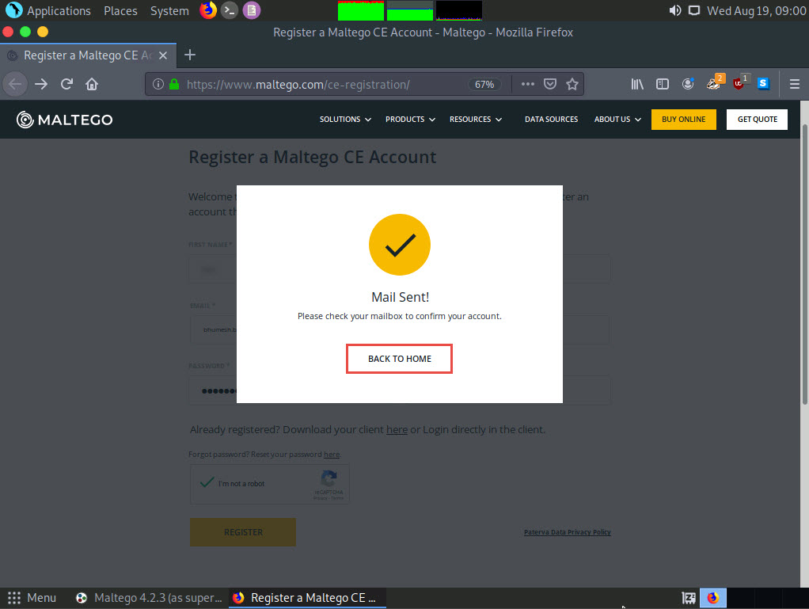

1. Now, in the browser window, click '**+**' icon to open a new tab. Open the email account given at the time of registration in **step#7**. Open the mail from **Maltego** and click on the activation link.

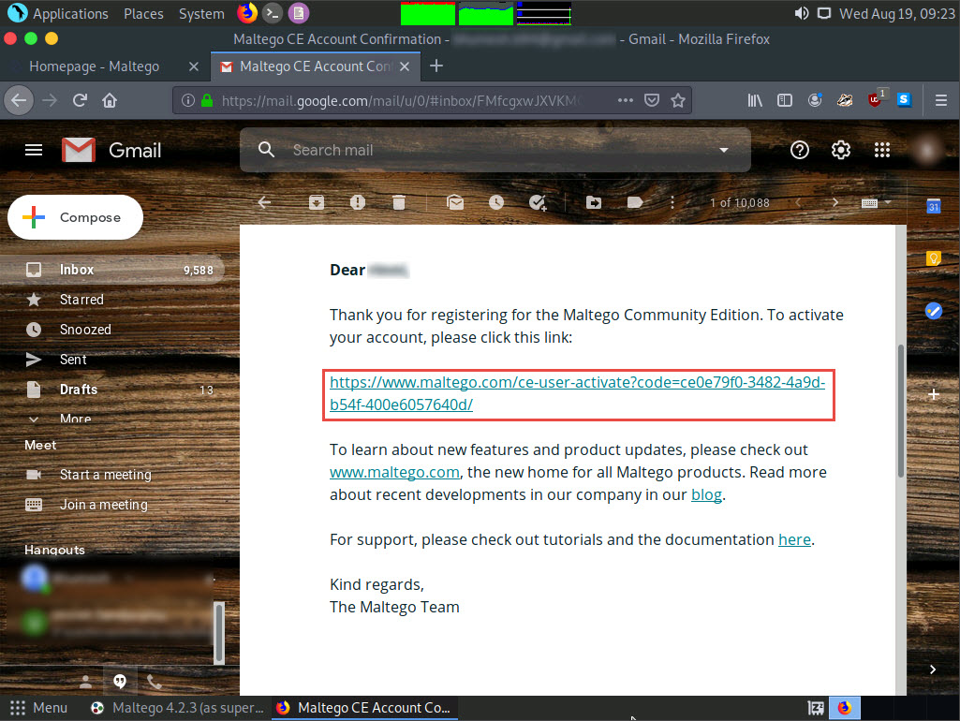

1. **Account Successfully Activated!** page appears, as shown in the screenshot.

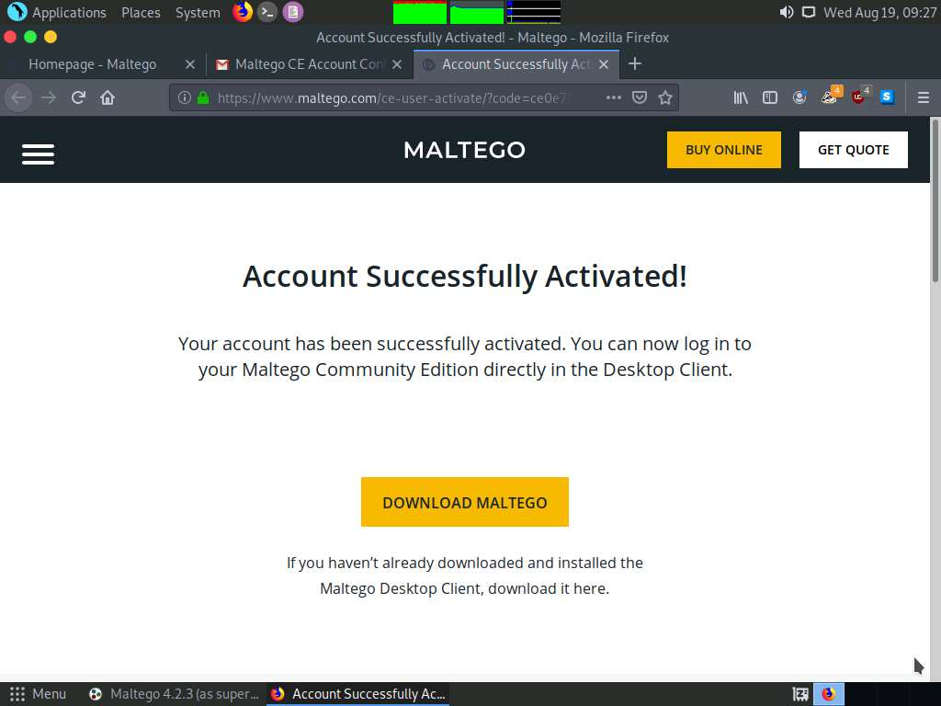

1. Minimize the web browser and go back to the setup wizard and enter the **Email Address** and **Password** specified at the time of registration; solve the captcha and click **Next**.

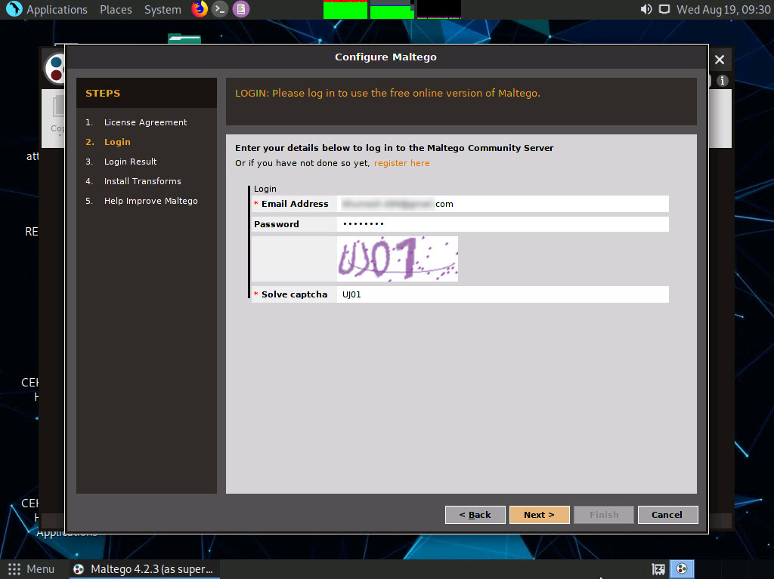

1. The **Login Result** section displays your personal details; click **Next**.

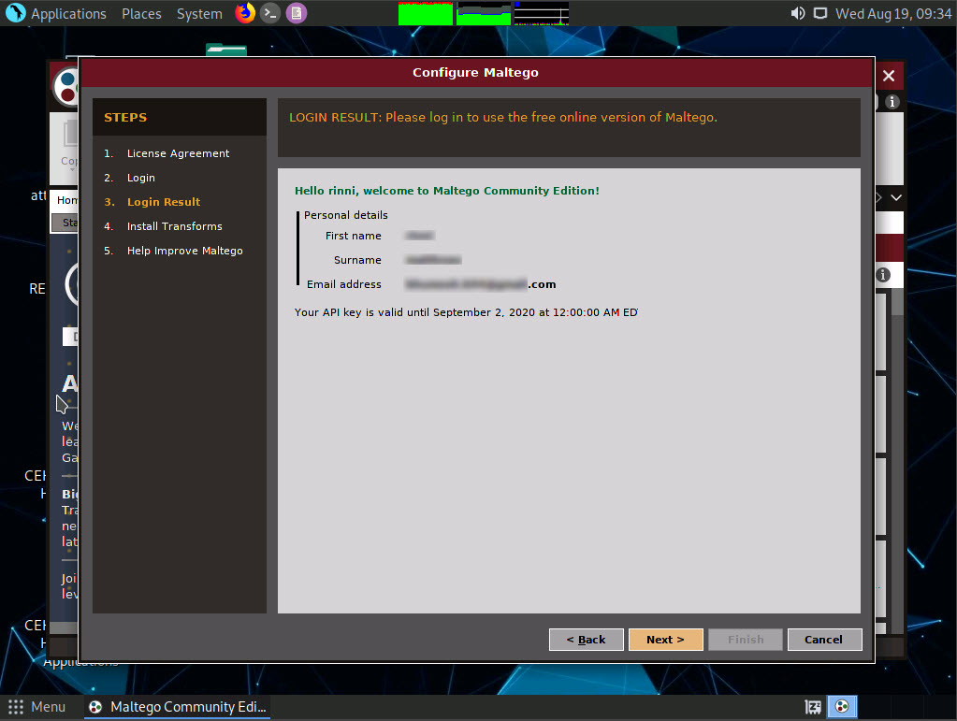

1. The **Install Transforms** section appears, which will install items from the chosen transform server. Leave the settings to default and click **Next**.

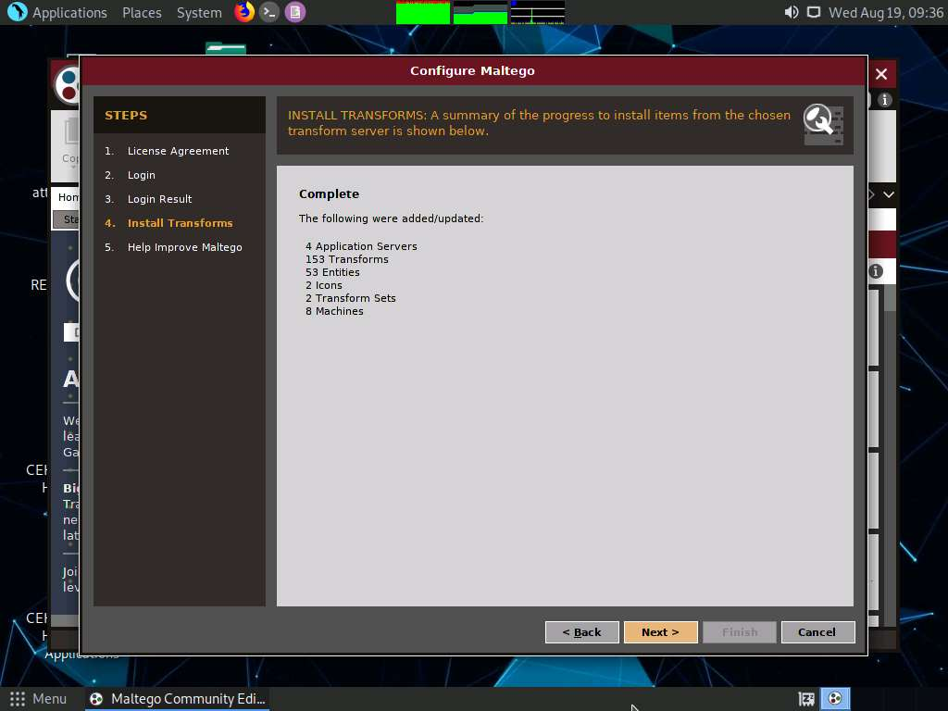

1. The **Help Improve Maltego** section appears. Leave the options set to default and click **Next**.
2. The **Privacy Mode Options** section appears. Leave the options set to default and click **Next**.
3. The **Ready** section appears, select **Open a blank graph and let me play around** option and click **Finish**.
4. The **Maltego Community Edition** GUI appears, along with **Privacy Policy Change Notice**, click **Acknowledge** button.
5. The **Maltego Community Edition** window along with the **New Graph (1)** window appears, as shown in the screenshot.

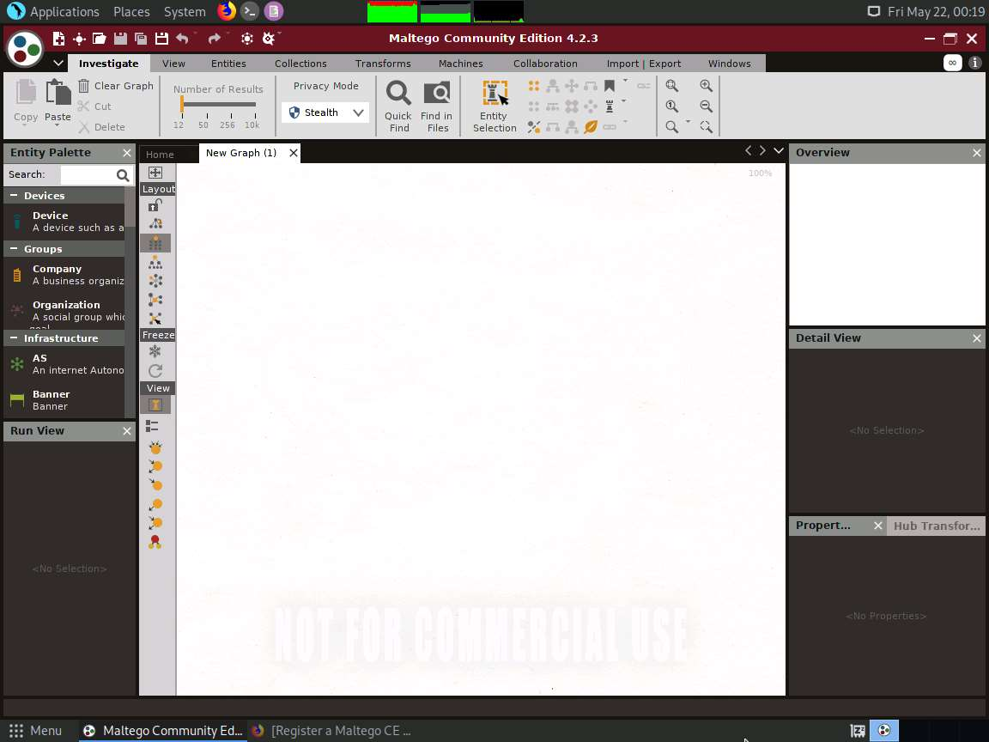

1. In the left-pane of **Maltego GUI**, you can find the **Entity Palette** box, which contains a list of default built-in transforms. In the **Infrastructure** node under **Entity Palette**, observe a list of entities such as **AS**, **DNS Name**, **Domain**, **IPv4 Address**, **URL**, **Website**, etc.
2. Drag the **Website** entity onto the **New Graph (1)** window.
3. The entity appears on the new graph, with the **www.paterva.com** URL selected by default.

If you are not able to view the entity as shown in the screenshot, click in **the New Graph (1)** window and **scroll up**, which will increase the size of the entity.

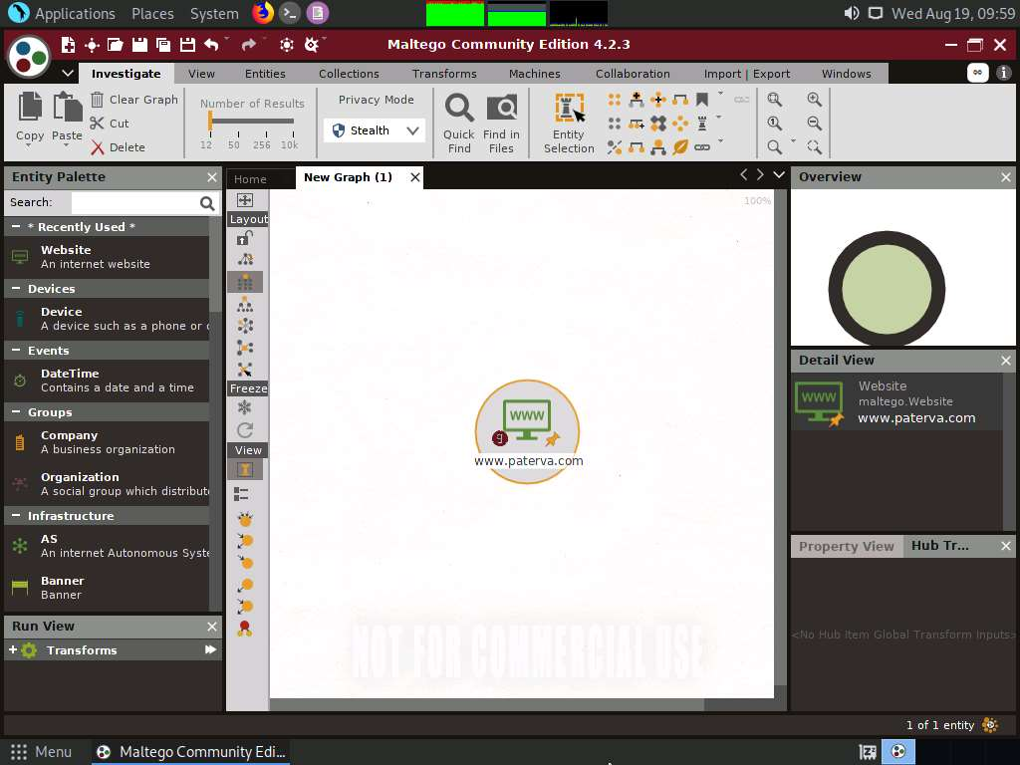

1. Double-click the name **www.paterva.com** and change the domain name to **www.certifiedhacker.com**; press **Enter**.

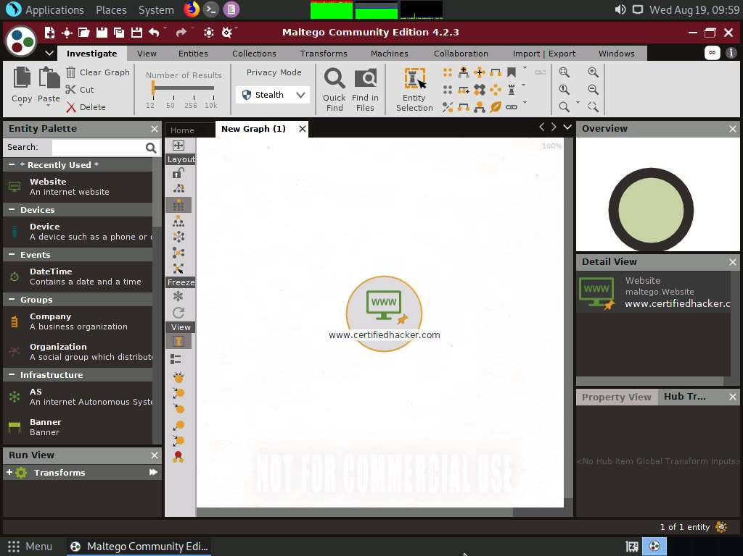

1. Right-click the entity and select **All Transforms**.

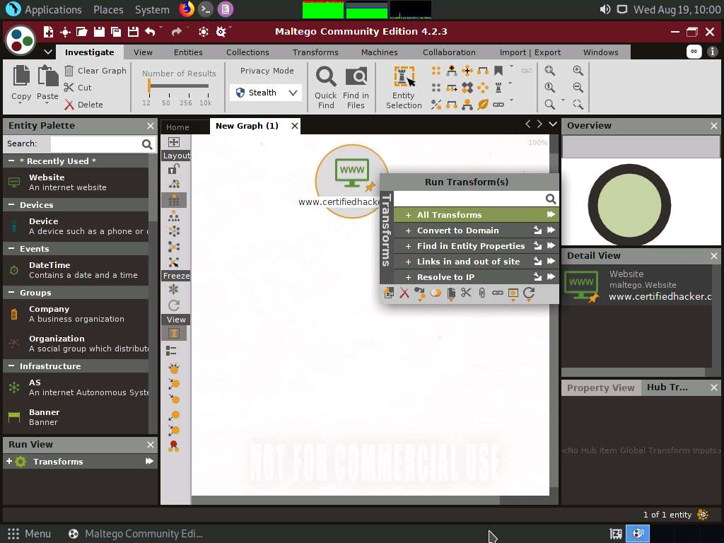

1. The **Run Transform(s)** list appears; click **To Domains [DNS]**.

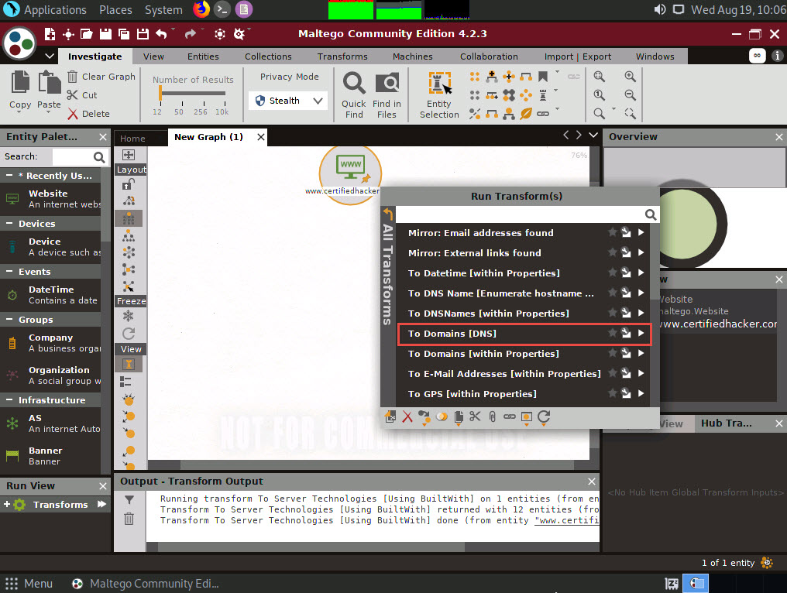

1. The domain corresponding to the website displays, as shown in the following screenshot.

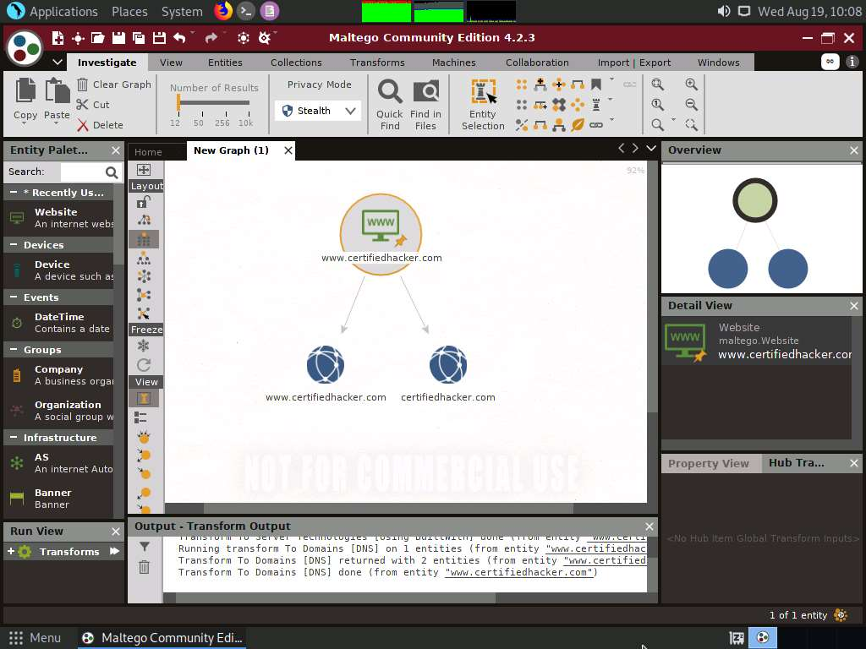

1. Right-click the **certifiedhacker.com** entity and select **All Transforms** ---> **To DNS Name [Using Name Schema diction…]**.

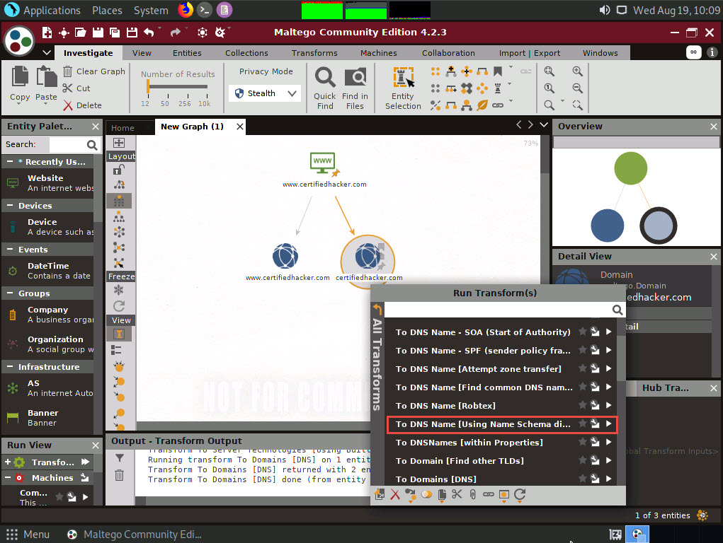

1. Observe the status in the progress bar. This transform will attempt to test various name schemas against a domain and try to identify a specific name schema for the domain, as shown in the following screenshot.

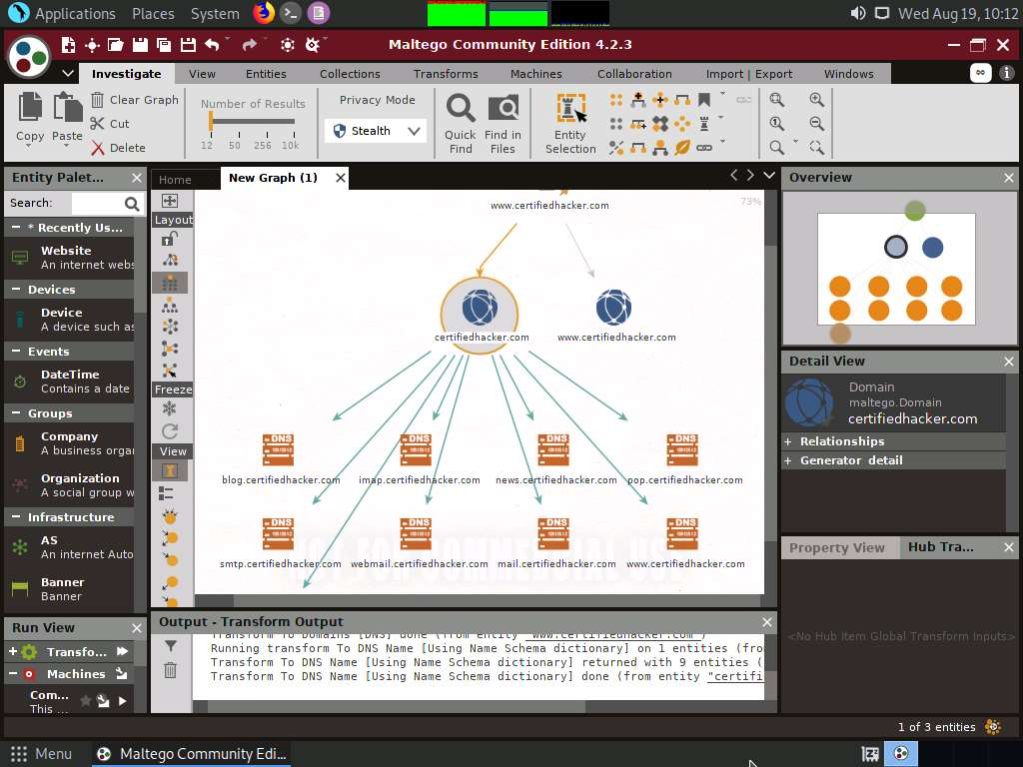

1. After identifying the name schema, attackers attempt to simulate various exploitation techniques to gain sensitive information related to the resultant name schemas. For example, an attacker may implement a brute-force or dictionary attack to log in to **ftp.certifiedhacker.com** and gain confidential information.
2. Select only the name schemas by dragging and deleting them.

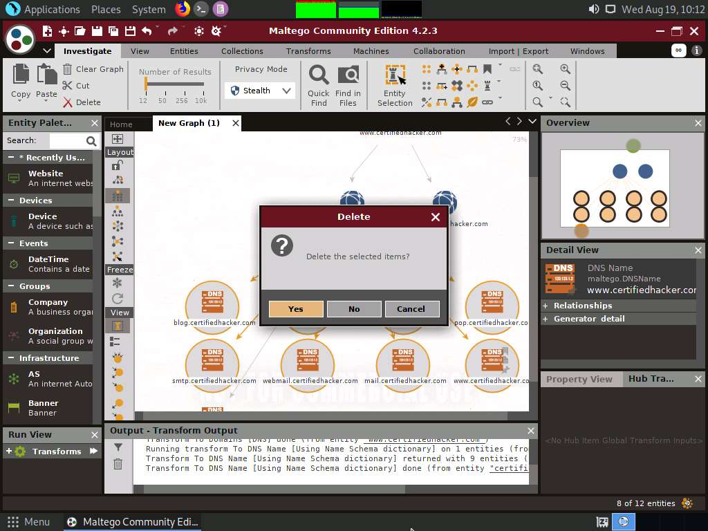

1. Right-click the **certifiedhacker.com** entity and select **All Transforms** --> **To DNS Name - SOA (Start of Authority)**.

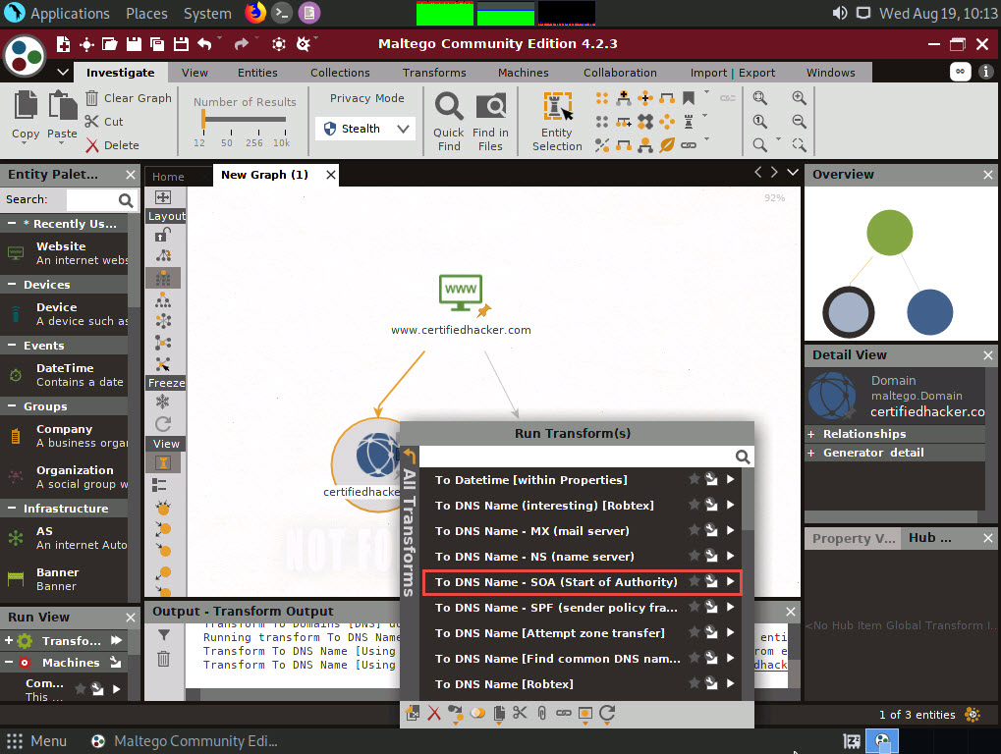

1. This returns the primary name server and the email of the domain administrator, as shown in the following screenshot.

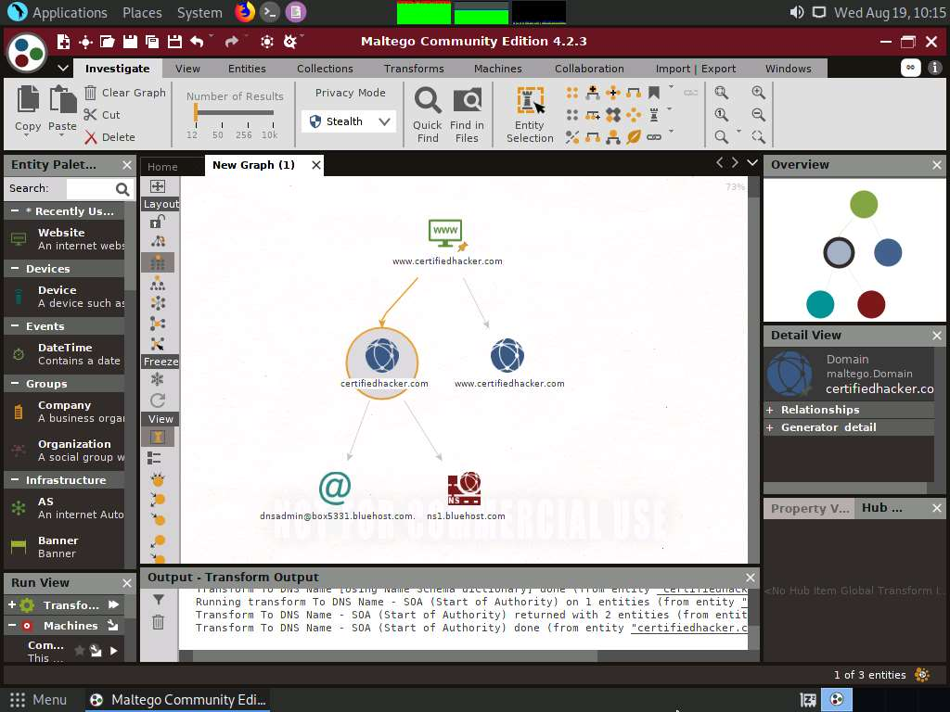

1. By extracting the SOA related information, attackers attempt to find vulnerabilities in their services and architectures and exploit them.
2. Select both the name server and the email by dragging and deleting them.

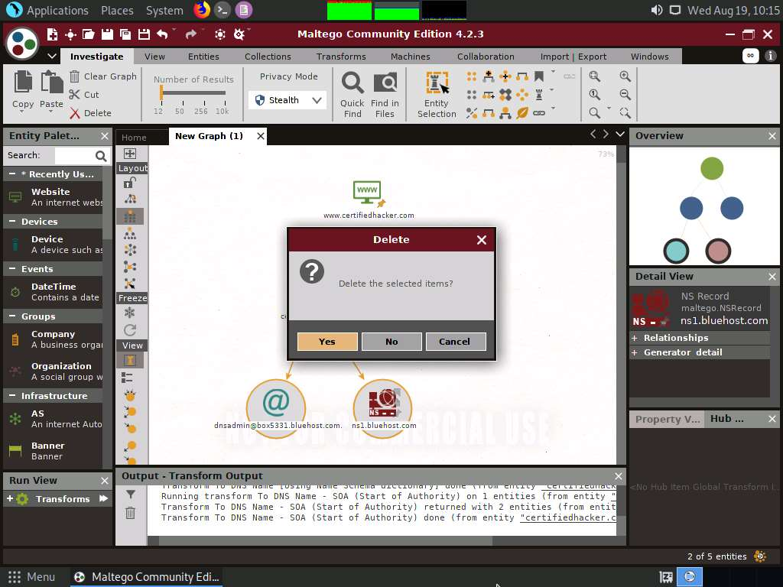

1. Right-click the **certifiedhacker.com** entity and select **All Transforms** --> **To DNS Name - MX (mail server)**.

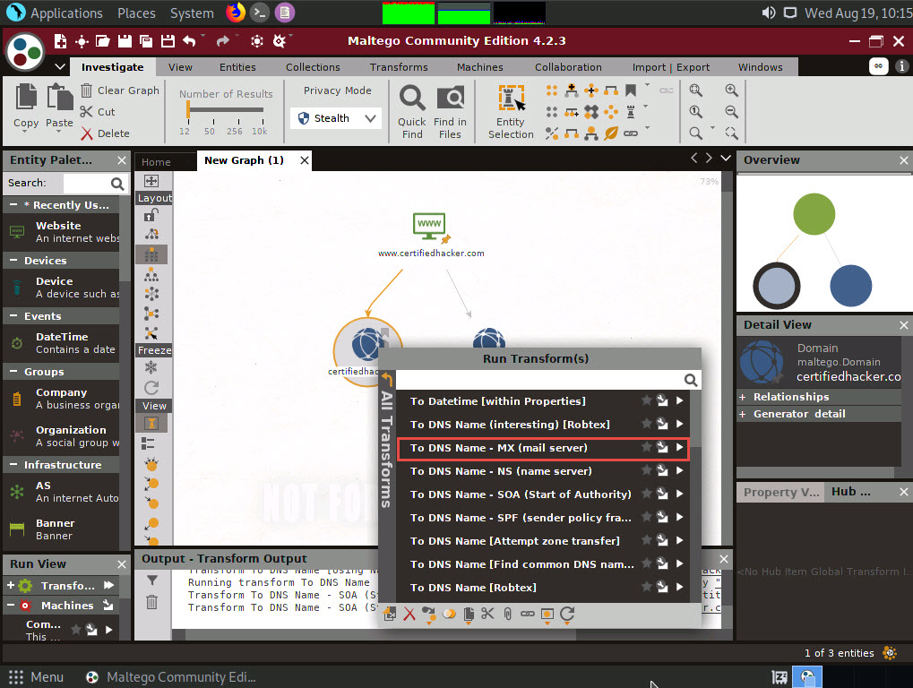

1. This transform returns the mail server associated with the certifiedhacker.com domain, as shown in the following screenshot.

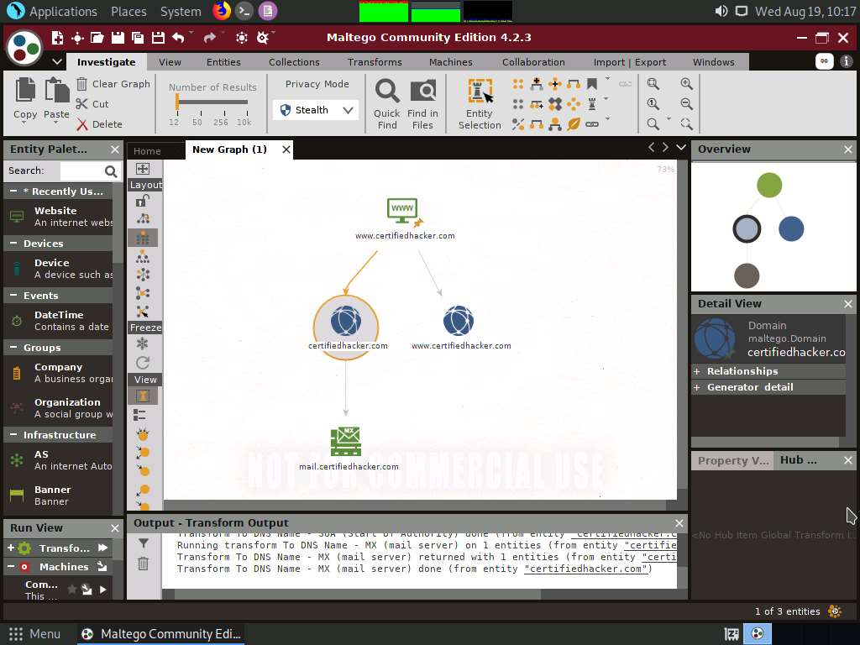

1. By identifying the mail exchanger server, attackers attempt to exploit the vulnerabilities in the server and, thereby, use it to perform malicious activities such as sending spam e-mails.
2. Select only the mail server by dragging and deleting it.

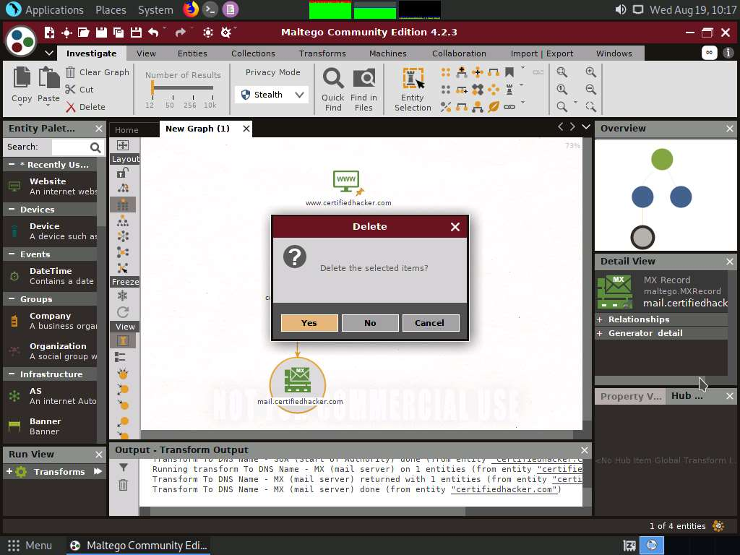

1. Right-click the **certifiedhacker.com** entity and select **All Transforms** --> **To DNS Name - NS (name server)**.

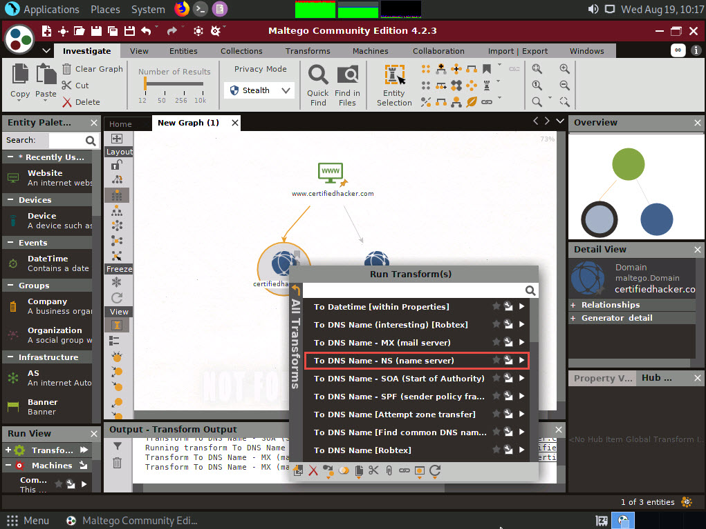

1. This returns the name servers associated with the domain, as shown in the following screenshot.
2. By identifying the primary name server, an attacker can implement various techniques to exploit the server and thereby perform malicious activities such as DNS Hijacking and URL redirection.
3. Select both the domain and the name server by dragging and deleting them.

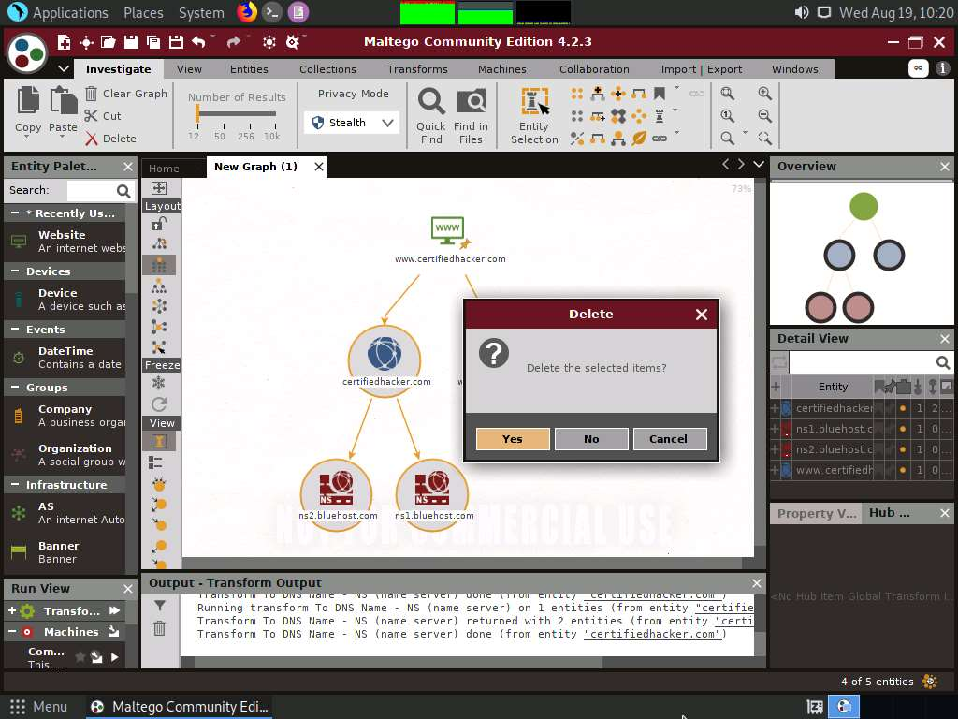

1. Right-click the entity and select **All Transforms** --> **To IP Address [DNS]**.

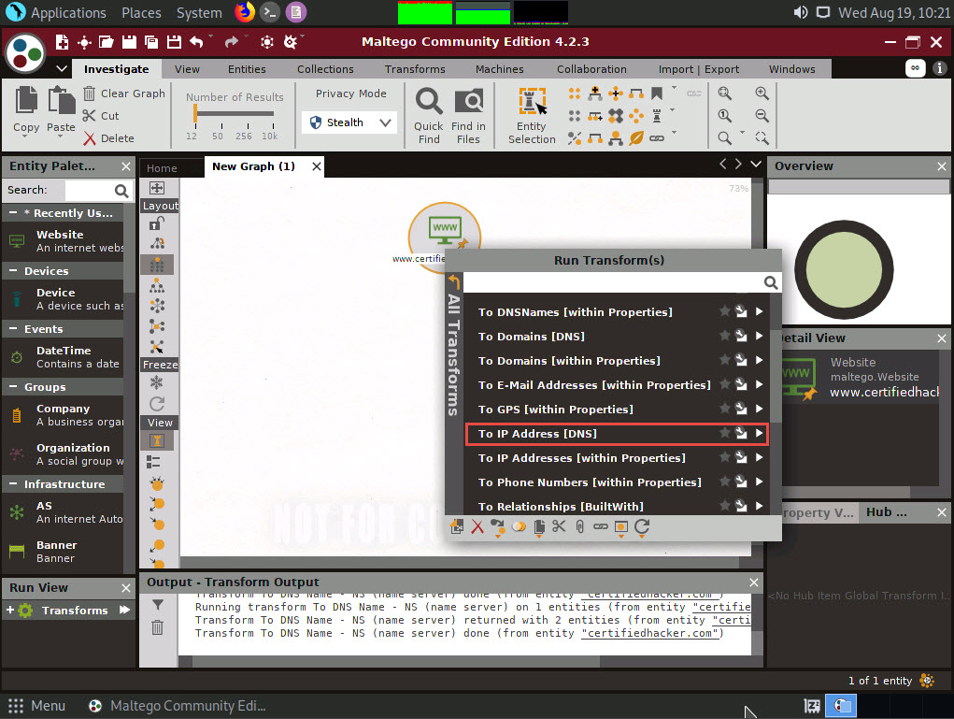

1. This displays the IP address of the website, as shown in the following screenshot.

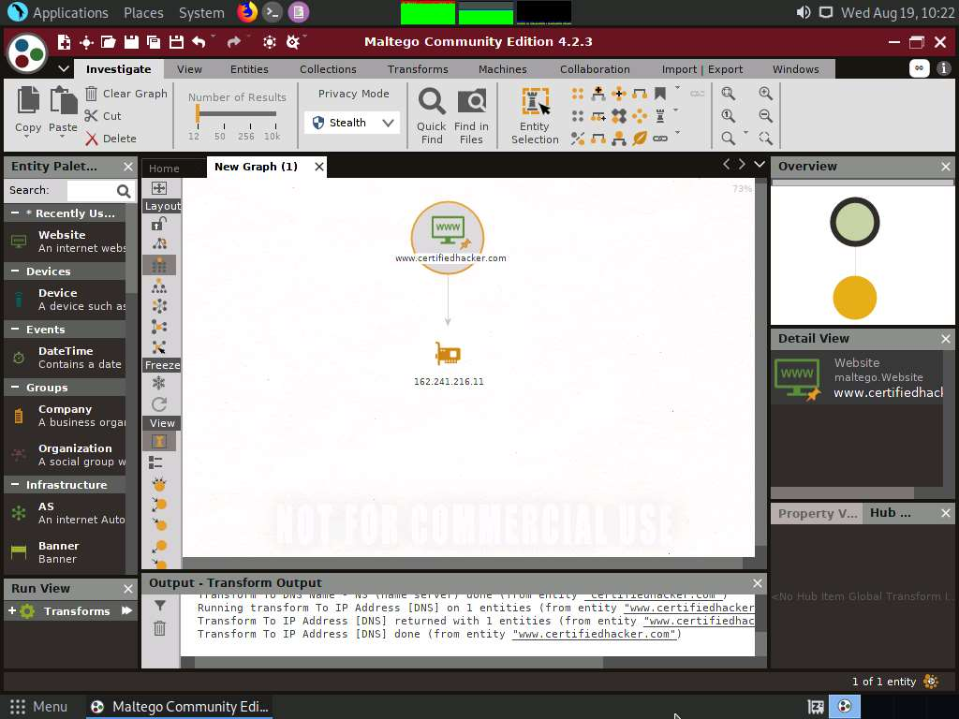

1. By obtaining the IP address of the website, an attacker can simulate various scanning techniques to find open ports and vulnerabilities and, thereby, attempt to intrude in the network and exploit them.
2. Right-click the IP address entity and select **All Transforms** --> **To location [city, country]**.

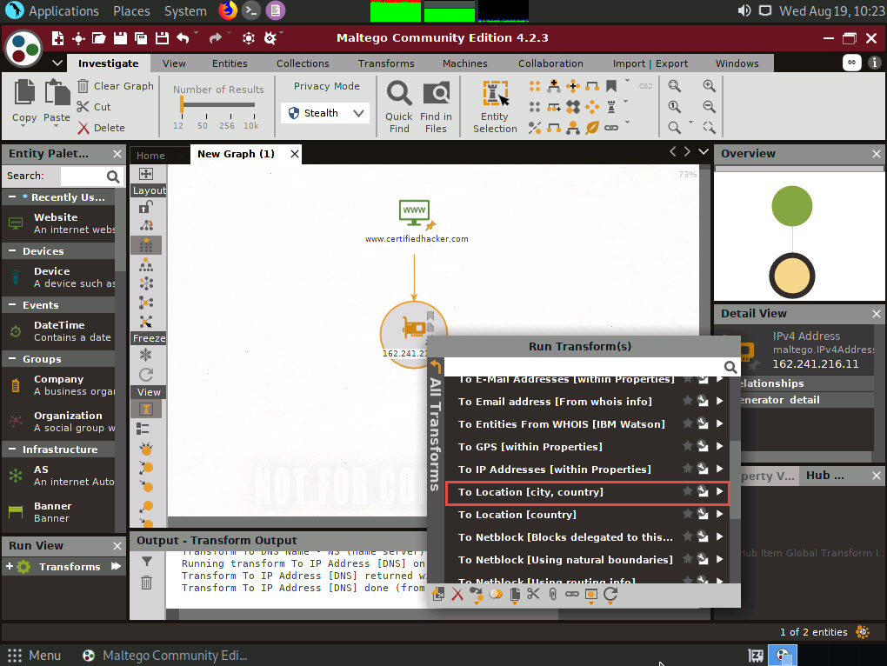

1. This transform identifies the geographical location of the IP address, as shown in the following screenshot.

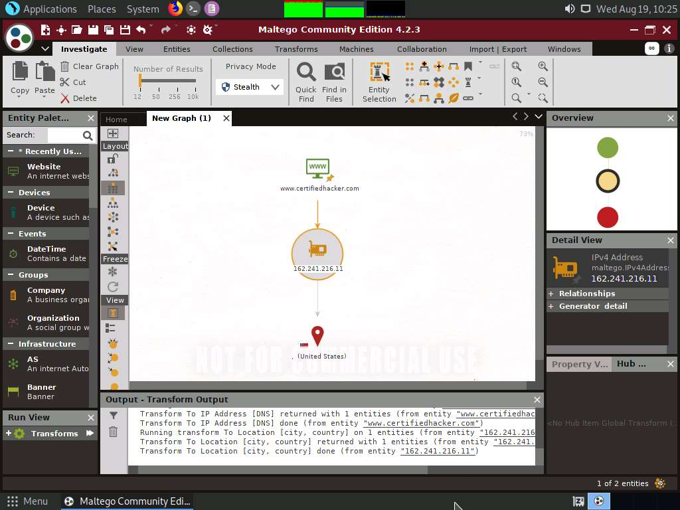

1. By obtaining the information related to geographical location, attackers can perform social engineering attacks by making voice calls (vishing) to an individual in an attempt to leverage sensitive information.
2. Now, right-click the **www.certifiedhacker.com** website entity and select **All Transforms** --> **To Domains [DNS]**. The domains corresponding to the website display, as shown in the screenshot.

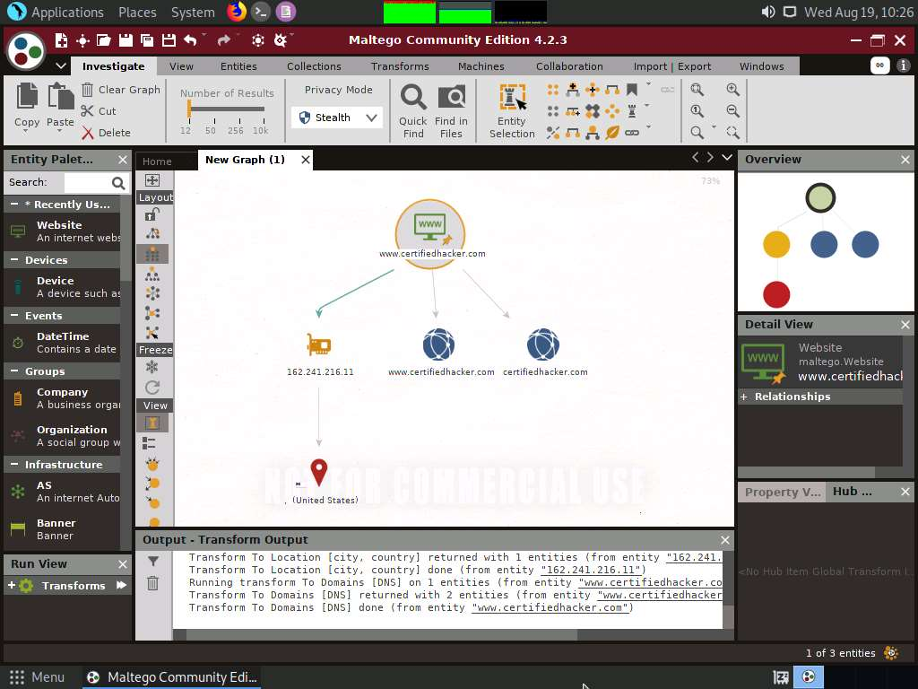

1. Right-click the domain entity (**certifiedhacker.com**) and select **All Transform** --> **To Entities from WHOIS [IBM Watson]**.

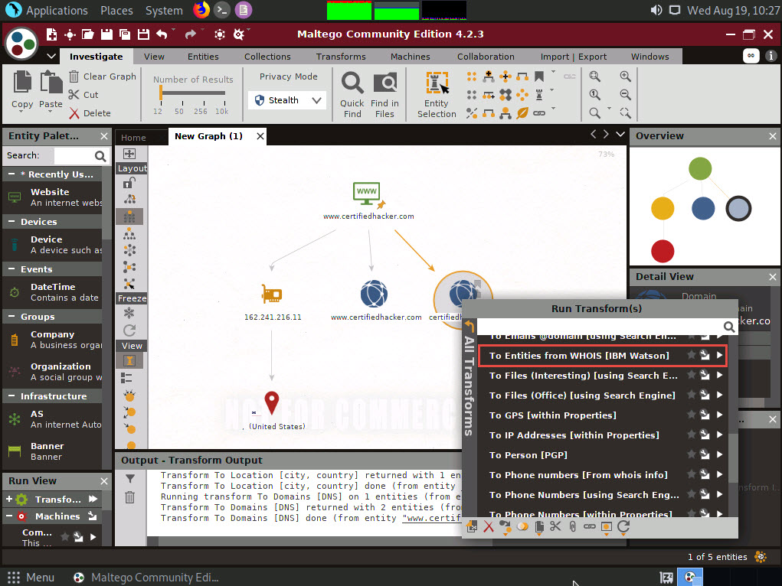

1. This transform returns the entities pertaining to the owner of the domain, as shown in the following screenshot.

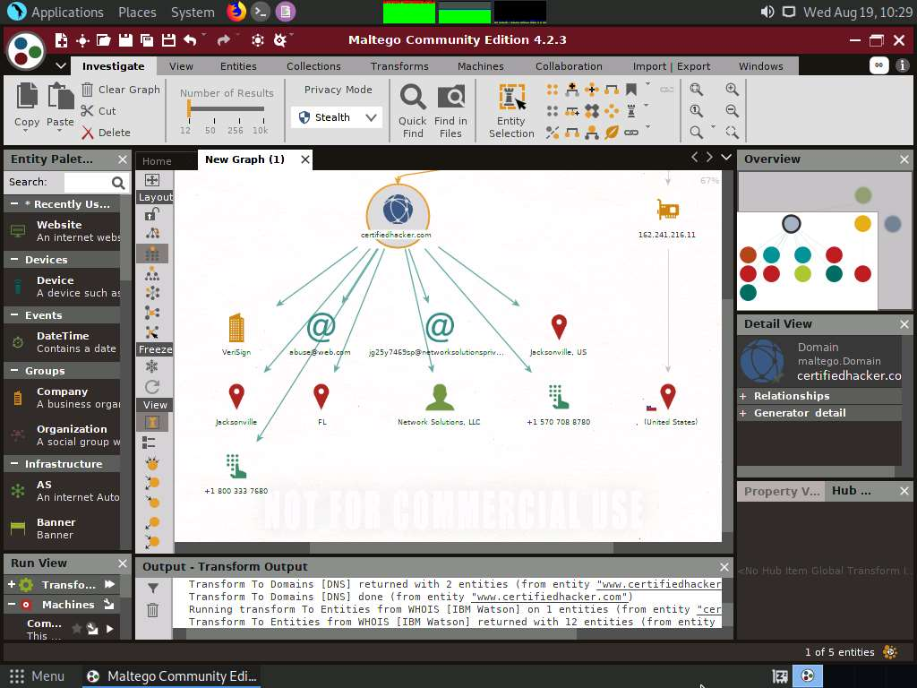

1. By obtaining this information, you can exploit the servers displayed in the result or simulate a brute force attack or any other technique to hack into the admin mail account and send phishing emails to the contacts in that account.
2. Apart from the aforementioned methods, you can perform footprinting on the critical employee from the target organization to gather additional personal information such as email addresses, phone numbers, personal information, image, alias, phrase, etc.
3. In the left-pane of the Maltego GUI, click the **Personal** node under **Entity Palette** to observe a list of entities such as **Email Address**, **Phone Numbers**, **Image**, **Alias**, **Phrase**, etc.

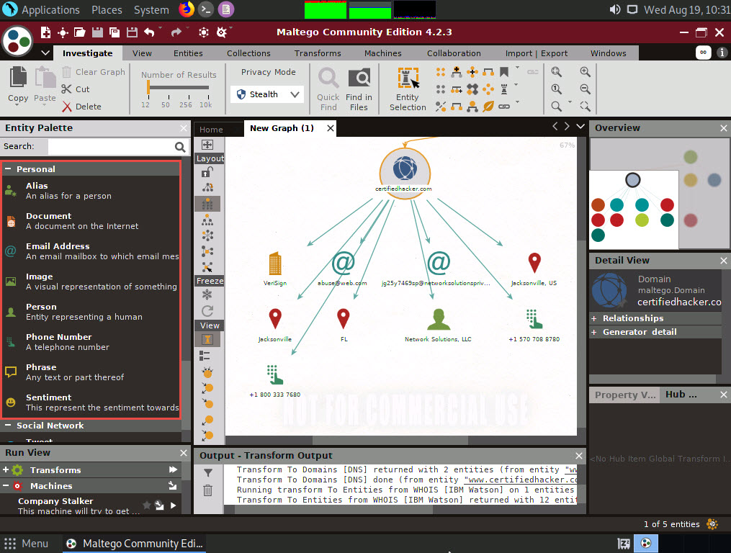

1. Apart from the transforms mentioned above, other transforms can track accounts and conversations of individuals who are registered on social networking sites such as Twitter. Extract all possible information.
2. By extracting all this information, you can simulate actions such as enumeration, web application hacking, social engineering, etc., which may allow you access to a system or network, gain credentials, etc.
3. This concludes the demonstration of footprinting a target using Maltego.
4. Close all open windows and document all the acquired information.

Task 3: Footprinting a Target using OSRFramework

OSRFramework is a set of libraries that are used to perform Open Source Intelligence tasks. They include references to many different applications related to username checking, DNS lookups, information leaks research, deep web search, regular expressions extraction, and many others. It also provides a way of making these queries graphically as well as several interfaces to interact with such as OSRFConsole or a Web interface.

1. Click [Parrot Security](https://labclient.labondemand.com/Instructions/b16bedc2-7151-47a3-9211-5daccdd8c426?rc=10) to switch to the **Parrot Security** machine. Click the **MATE Terminal** icon at the top-left corner of the **Desktop** window to open a **Terminal** window.



1. A **Parrot Terminal** window appears. In the terminal window, type **sudo su** and press **Enter** to run the programs as a root user.
2. In the **[sudo] password for attacker** field, type **toor** as a password and press **Enter**.

The password that you type will not be visible.

1. Now, type **cd** and press **Enter** to jump to the root directory.
2. Use **usufy.py** to check for the existence of a profile for given user details on different social networking platforms. Type **usufy.py -n [target user name or profile name] -p [target platform]** (here, the target user name or profile is **Mark Zuckerberg** and the target platforms are **twitter**, **facebook**, and **youtube**) and press **Enter**.

**-n** is the list of nicknames to process and **-p** is for the platform for search.

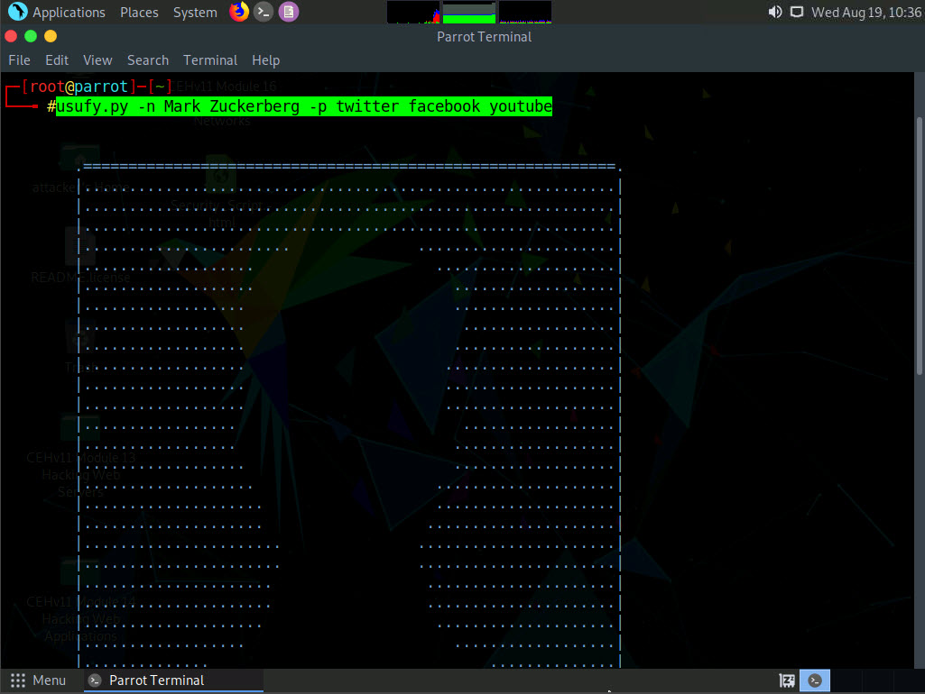

1. The usufy.py will search the user details in the mentioned platforms and will provide you with the existence of the user, as shown in the screenshot.

If you do not get results as intended, keep pressing **Ctrl+C** untill you see the results, as shown in the screenshot.

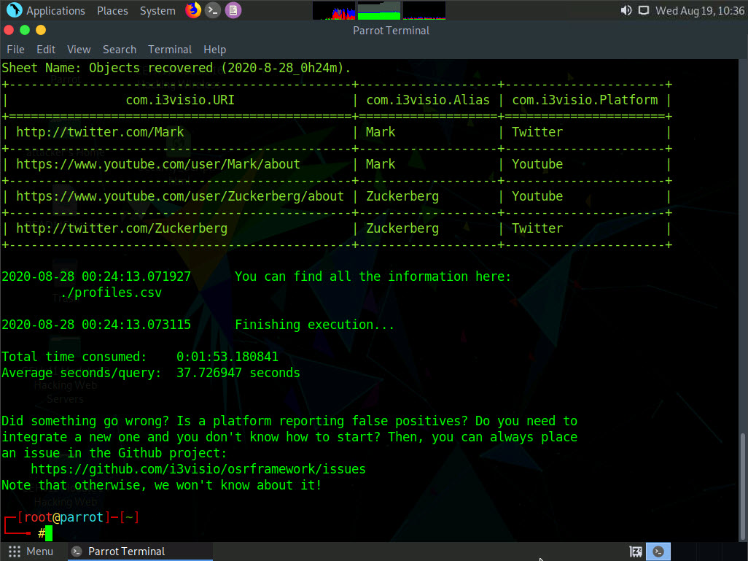

1. Use **domainfy.py** to check with the existing domains using words and nicknames. Type **domainfy.py -n [Domain Name] -t all** (here, the target domain name is **ECCOUNCIL**) and press **Enter**.

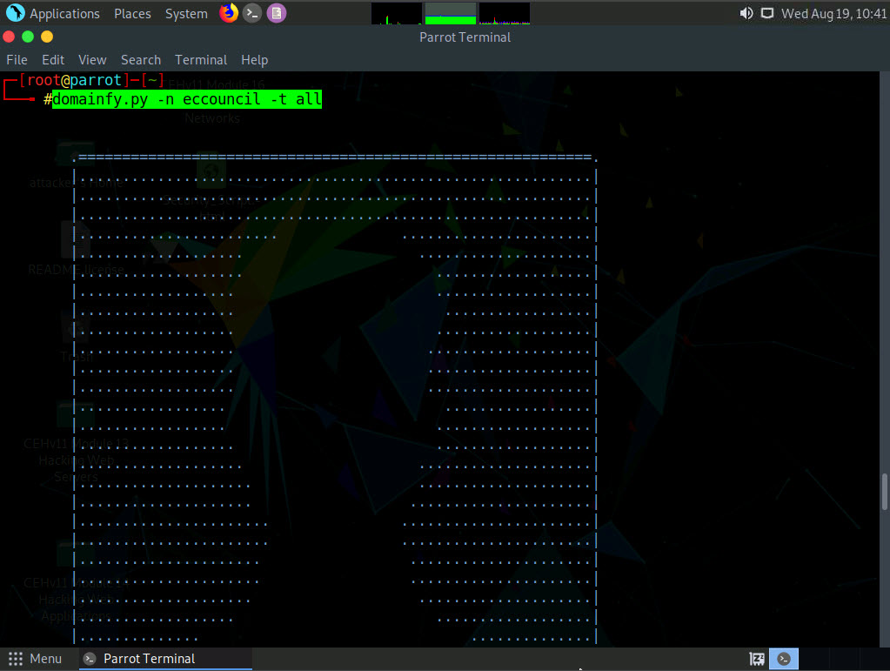

1. The tool will retrieve all the domains related to the target domain.

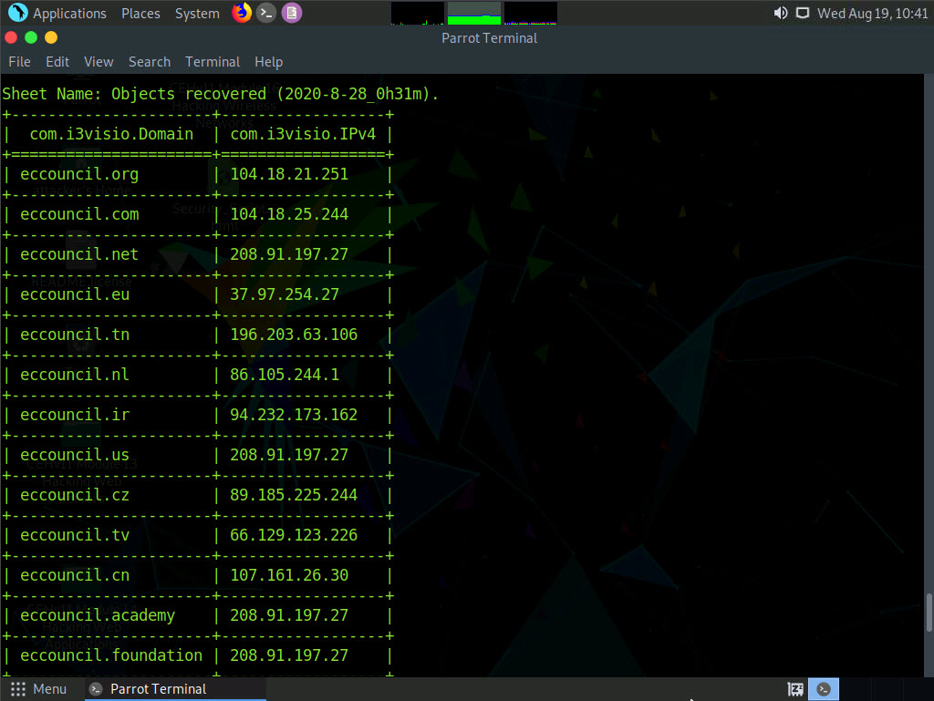

1. Similarly, you can use following OSRFramework packages to gather information about the target.
   * **searchfy.py** - Gathers information about the users on social networking pages.
   * **mailfy.py** – Gathers information about email accounts
   * **phonefy.py** – Checks for the existence of a given series of phones
   * **entify.py** – Extracts entities using regular expressions from provided URLs
2. This concludes the demonstration of gathering information about the target user aliases from multiple social media platforms using OSRFramework.
3. Close all open windows and document all the acquired information.

Task 4: Footprinting a Target using BillCipher

BillCipher is an information gathering tool for a Website or IP address. Using this tool, you can gather information such as DNS Lookup, Whois lookup, GeoIP Lookup, Subnet Lookup, Port Scanner, Page Links, Zone Transfer, HTTP Header, etc. Here, we will use the BillCipher tool to footprint a target website URL.

1. Click [Parrot Security](https://labclient.labondemand.com/Instructions/b16bedc2-7151-47a3-9211-5daccdd8c426?rc=10) to switch to the **Parrot Security** machine. Click the **MATE Terminal** icon at the top-left corner of the **Desktop** window to open a **Terminal** window.



1. A **Parrot Terminal** window appears. In the terminal window, type **sudo su** and press **Enter** to run the programs as a root user.
2. In the **[sudo] password for attacker** field, type **toor** as a password and press **Enter**.

The password that you type will not be visible.

1. Now, type **cd** and press **Enter** to jump to the root directory.
2. A **Parrot Terminal** window appears. In the **Parrot Terminal** window, type **cd BillCipher** and press **Enter** to navigate to the BillCipher directory.

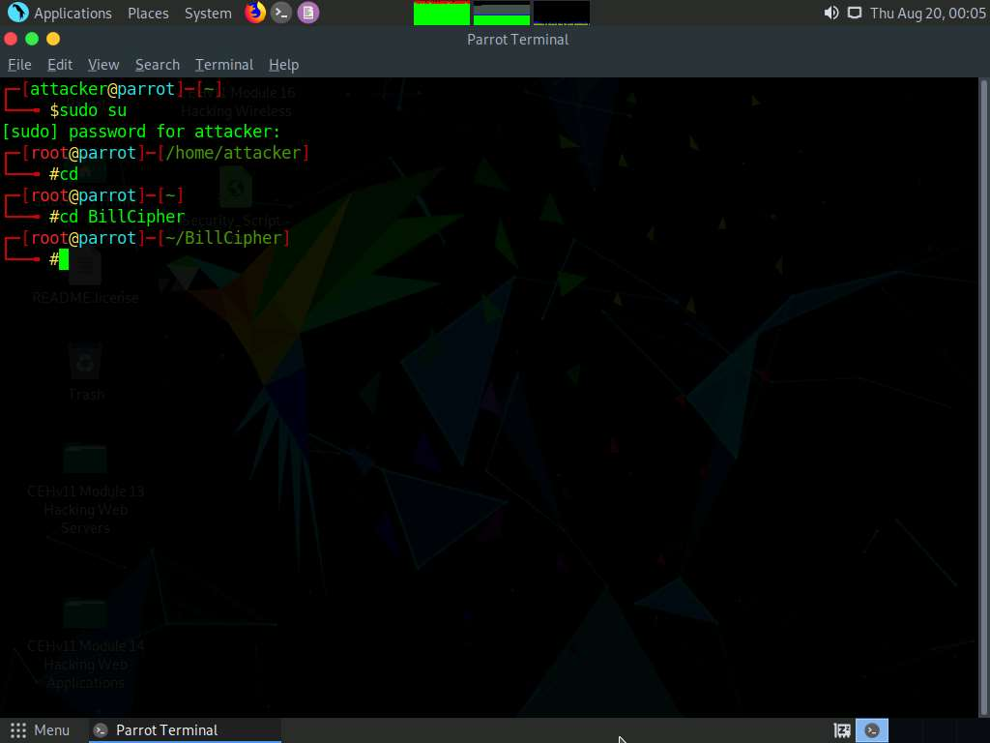

1. Now, type **python3 billcipher.py** and press **Enter** to launch the application.

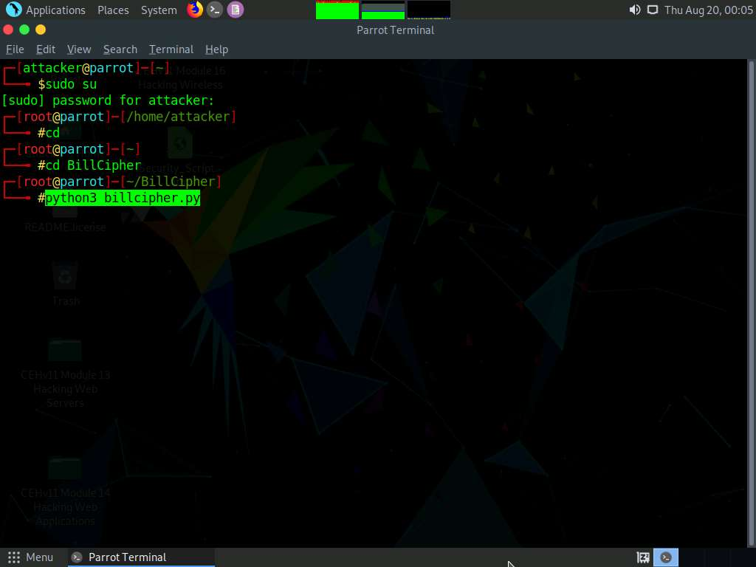

1. BillCipher application initializes. In the **Do you want to collect information of a website or IP address?** option, type **website** and press **Enter**.
2. In the **Enter the website address** option, type the target website URL (here, **www.certifiedhacker.com**) and press **Enter**.

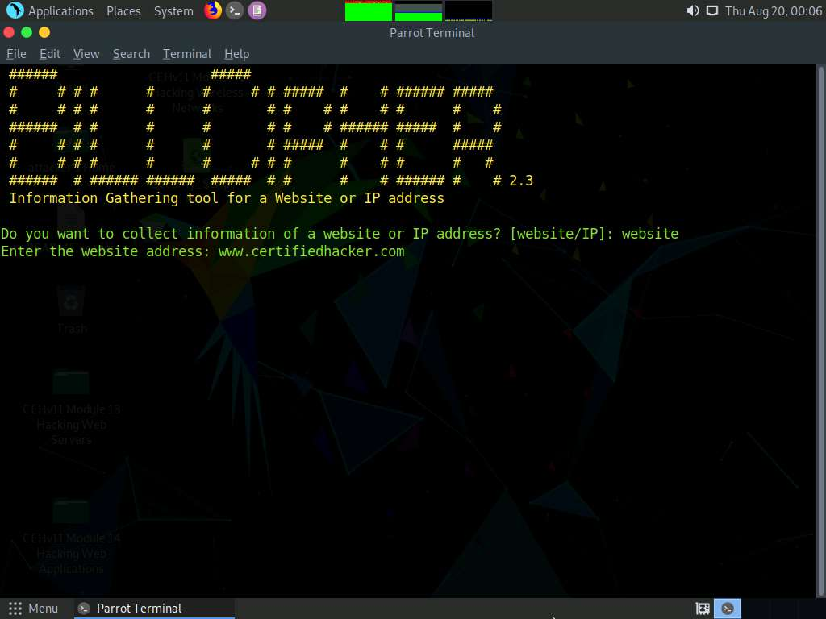

1. BillCipher displays various available options that you can use to gather information regarding a target website.
2. In the **What information would you like to collect?** option, type **1** to choose the **DNS Lookup** option and press **Enter**.

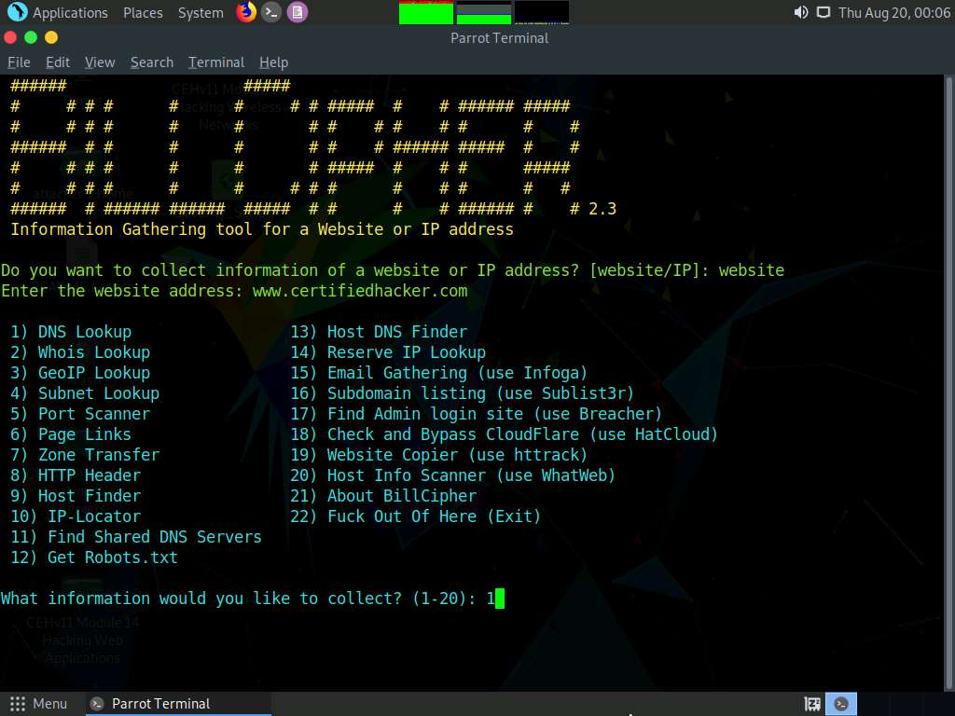

1. The result appears, displaying the DNS information regarding the target website, as shown in the screenshot.
2. In the **Do you want to continue?** option, type **Yes** and press **Enter** to continue.

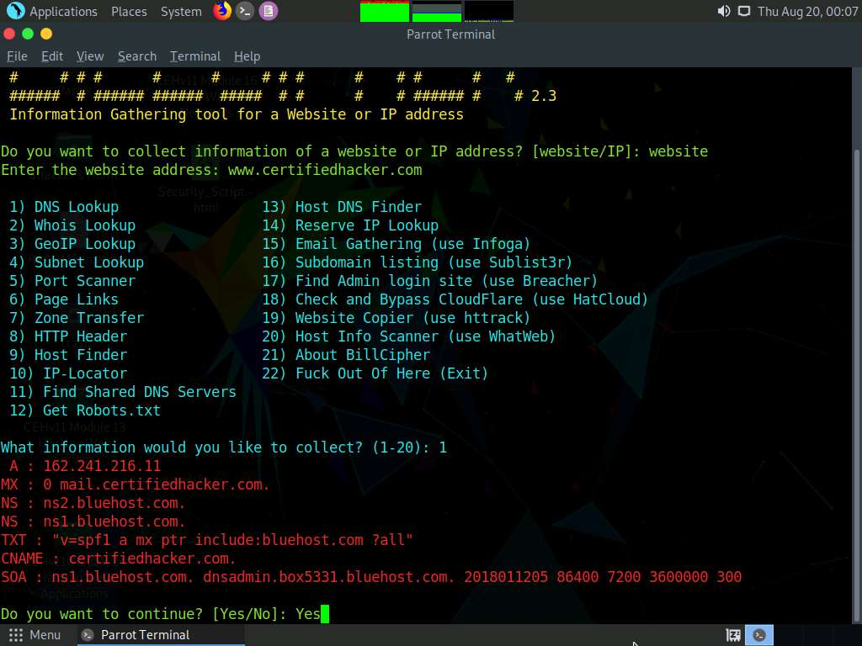

1. **Do you want to collect information of a website or IP address?** option appears, type **website** and press **Enter**.
2. In the **Enter the website address** option, type the target website URL (here, **www.certifiedhacker.com**) and press **Enter**.
3. Now, type **3** and press **Enter** to choose the **GeoIP Lookup** option from the available information gathering options.

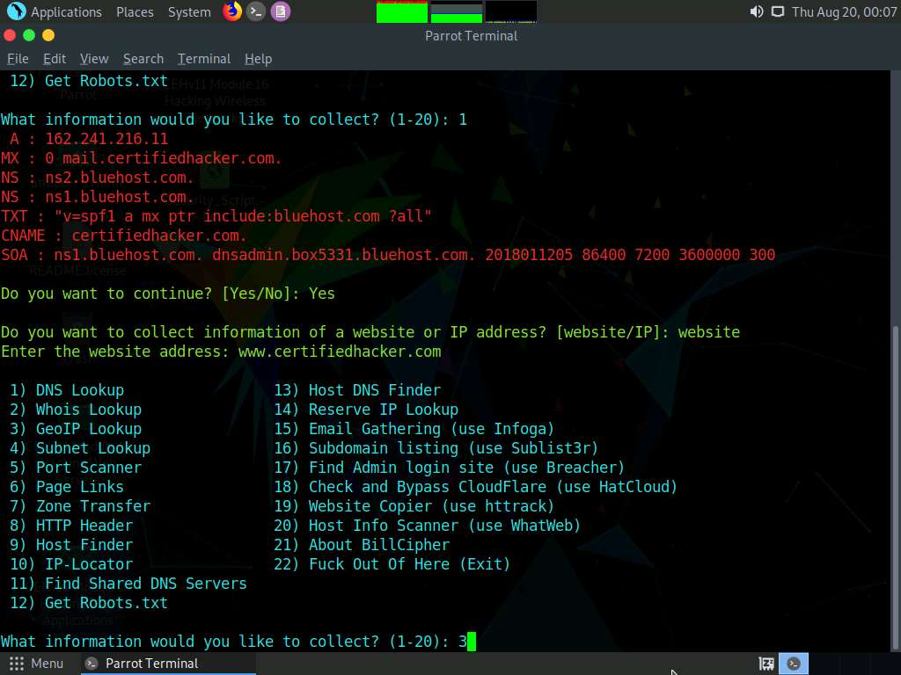

1. The result appears, displaying the **GeoIP Lookup** information of the target website, as shown in the screenshot.
2. In the **Do you want to continue?** option, type **Yes** and press **Enter** to continue.

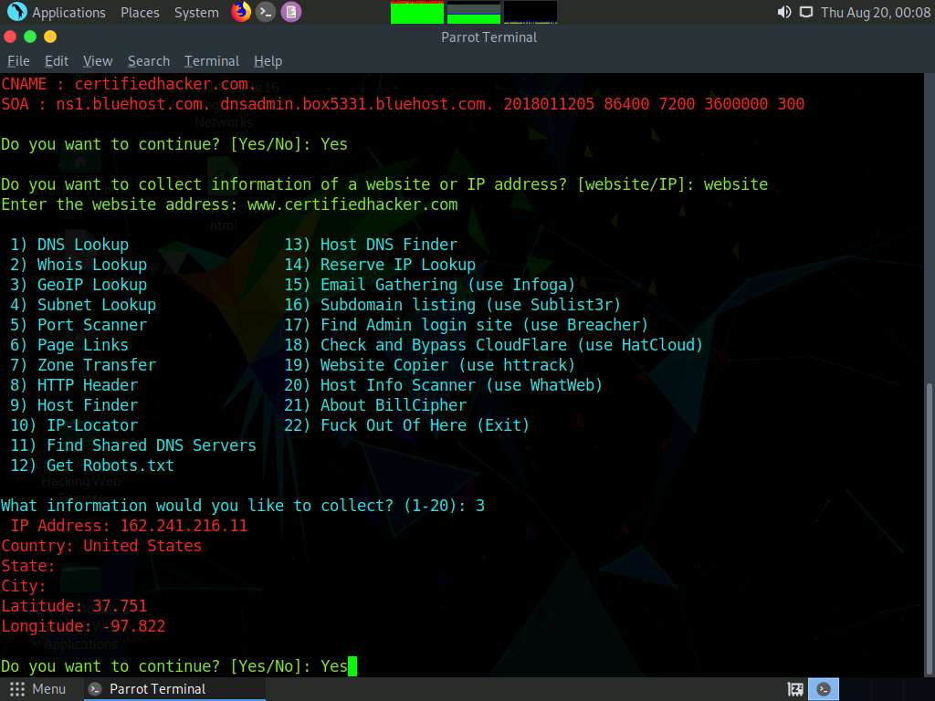

1. **Do you want to collect information of a website or IP address?** option appears, type **website** and press **Enter**.
2. In the **Enter the website address** option, type the target website URL (here, **www.certifiedhacker.com**) and press **Enter**.
3. Now, type **4** and press **Enter** to choose the **Subnet Lookup** option from the available information gathering options.

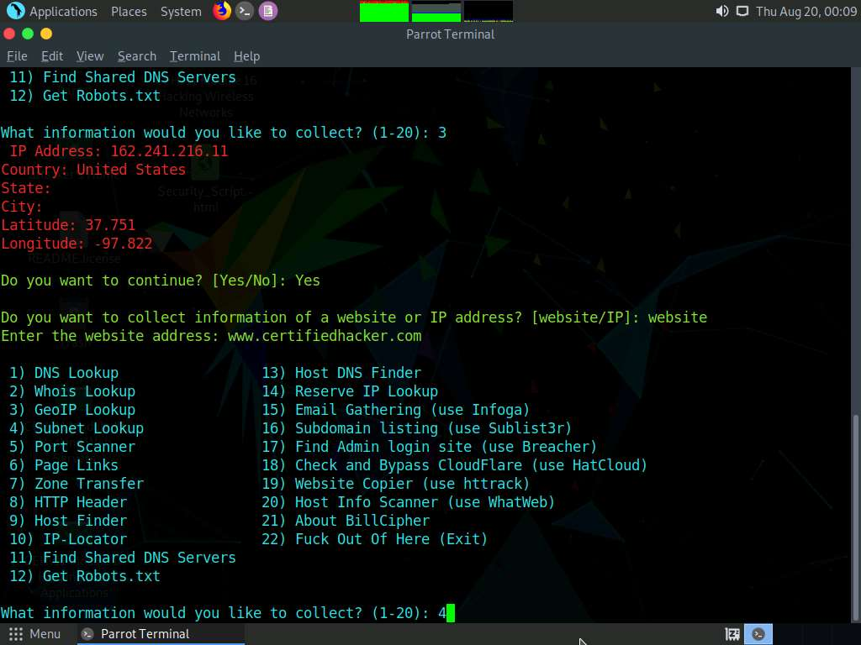

1. The result appears, displaying the **Subnet Lookup** information of the target website.
2. In the **Do you want to continue?** option, type **Yes** and press **Enter** to continue.

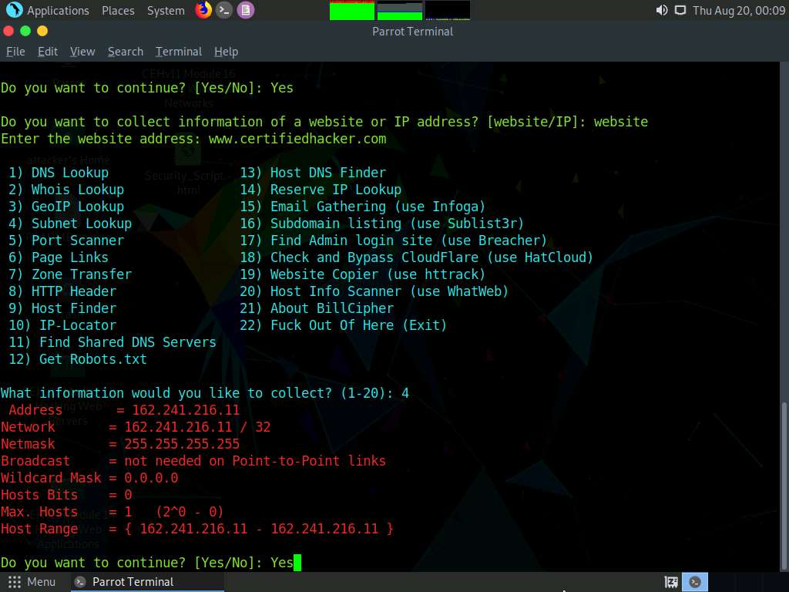

1. **Do you want to collect information of a website or IP address?** option appears, type **website** and press **Enter**.
2. In the **Enter the website address** option, type the target website URL (here, **www.certifiedhacker.com**) and press **Enter**.
3. Now, type **6** and press **Enter** to choose the **Page Links** option from the available information gathering options.
4. The result appears, displaying a list of **Visible links** and **Hidden links** of the target website, as shown in the screenshot.
5. In the **Do you want to continue?** option, type **Yes** and press **Enter** to continue.

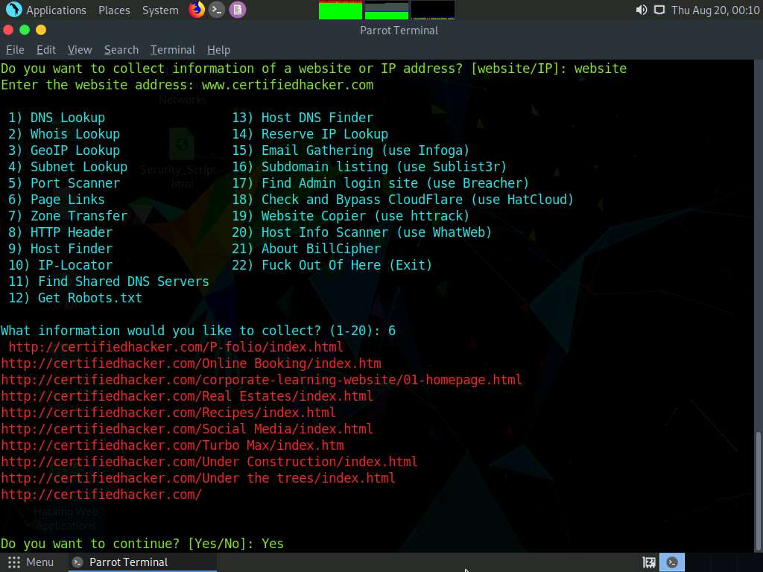

1. **Do you want to collect information of a website or IP address?** option appears, type **website** and press **Enter**.
2. In the **Enter the website address** option, type the target website URL (here, **www.certifiedhacker.com**) and press **Enter**.
3. Now, type **8** and press **Enter** to choose the **HTTP Header** option from the available information gathering options.
4. The result appears, displaying information regarding the HTTP header of the target website, as shown in the screenshot.
5. In the **Do you want to continue?** option, type **Yes** and press **Enter** to continue.

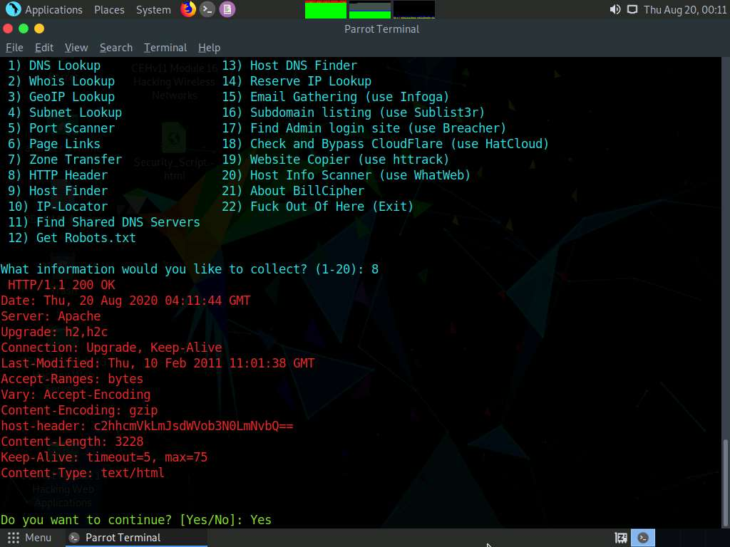

1. **Do you want to collect information of a website or IP address?** option appears, type **website** and press **Enter**.
2. In the **Enter the website address** option, type the target website URL (here, **www.certifiedhacker.com**) and press **Enter**.
3. Now, type **9** and press **Enter** to choose **Host Finder** option from the available information gathering option.
4. The result appears, displaying information regarding the IP address of the target website, as shown in the screenshot.3
5. In the **Do you want to continue?** option, type **Yes** and press **Enter** to continue.

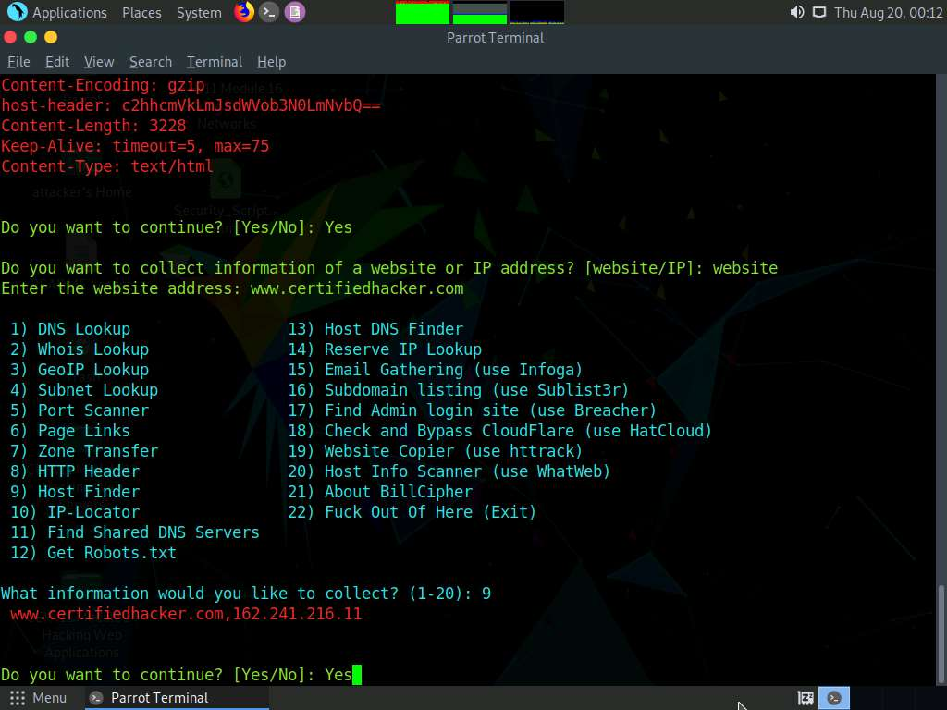

1. **Do you want to collect information of a website or IP address?** option appears, type **website** and press **Enter**.
2. In the **Enter the website address** option, type the target website URL (here, **www.certifiedhacker.com**) and press **Enter**.
3. Now, type **13** and press **Enter** to choose **Host DNS Finder** option from the available information gathering options.
4. The result appears, displaying information regarding host DNS of the target website, as shown in the screenshot.
5. In the **Do you want to continue?** option, type **Yes** and press **Enter** to continue.

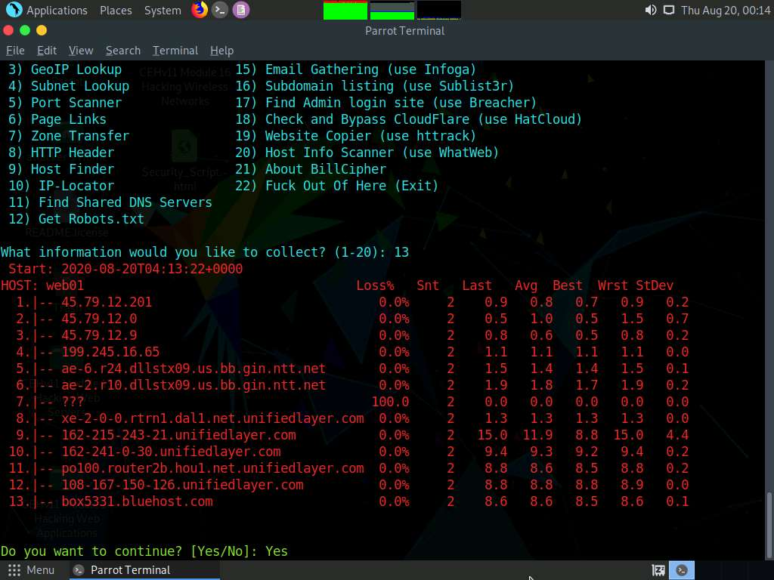

1. **Do you want to collect information of a website or IP address?** option appears, type **website** and press **Enter**.
2. In the **Enter the website address** option, type the target website URL (here, **www.certifiedhacker.com**) and press **Enter**.
3. Now, type **19** and press **Enter** to choose the **Website Copier (use httrack)** option from the available information gathering options.
4. The tool starts mirroring the target website; this will take approximately 5 minutes.
5. After completion of the mirroring process, the mirrored website gets saved in the folder **websource**, as shown in the screenshot.
6. In the **Do you want to continue?** option, type **No** and press **Enter** to exit **BillCiper**.

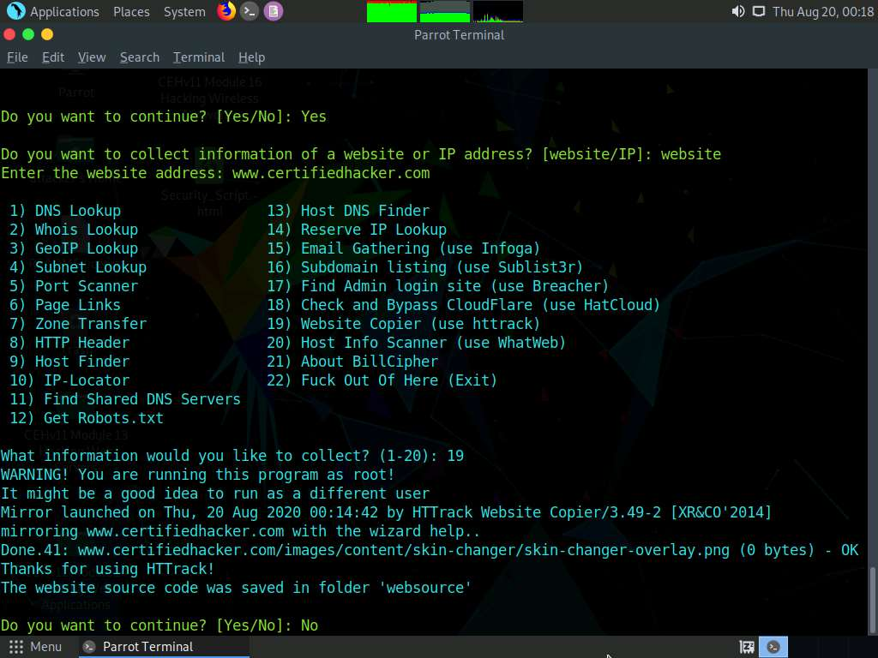

1. Now, click **Places** from the top section of the **Desktop** and click **Home Folder** from the context menu.

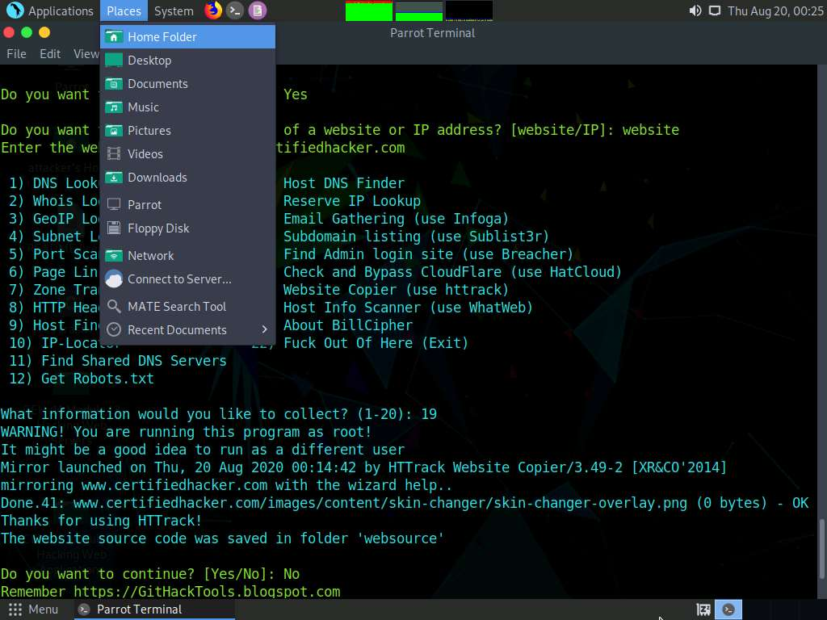

1. The **attacker** window appears, click **File System** from the left-pane and then double-click **root** from the right-pane.

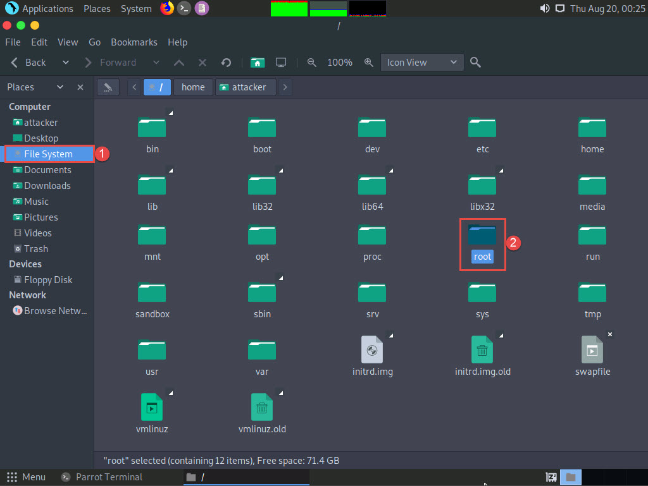

1. The **root** directory window appears; navigate to **BillCipher** --> **websource** --> **www.certifiedhacker.com** --> **www.certifiedhacker.com**. Right-click the **index.html** file and navigate to **Open With** --> **Firefox** to open the mirrored website.

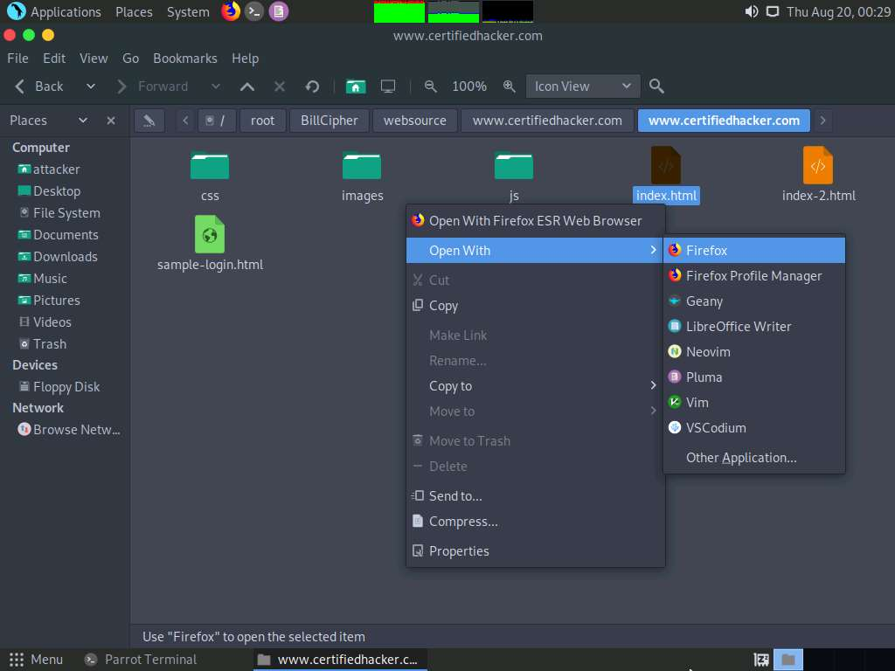

1. The mirror target website (**www.certifiedhacker.com**) appears in the **Mozilla Firefox** browser, as shown in the screenshot.

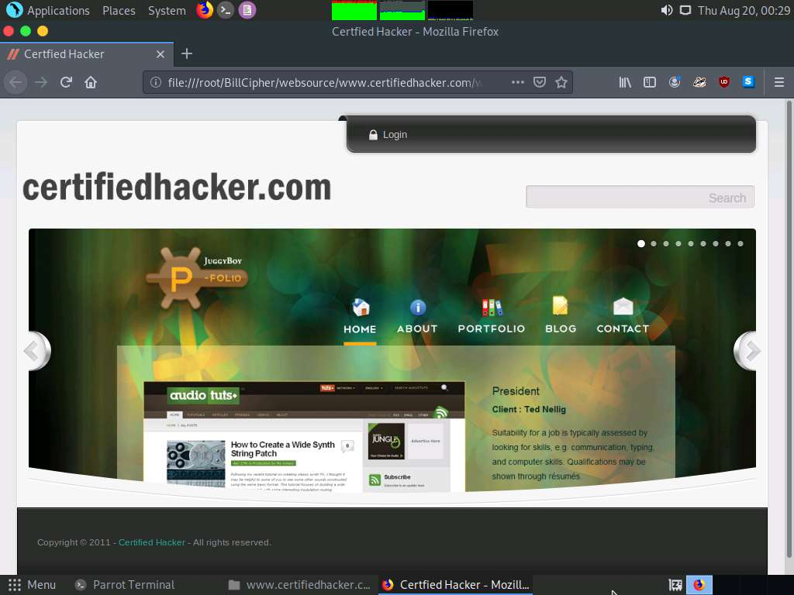

1. Similarly, you can use other information gathering options to gather information about the target.
2. This concludes the demonstration of footprinting the target website URL using BillCipher.
3. You can also use footprinting tools such as **Recon-Dog** (https://www.github.com), **Th3Inspector** (https://github.com), **Raccoon** (https://github.com), **Orb** (https://github.com), etc. to gather additional information related to the target company.
4. Close all open windows and document all the acquired information.

Task 5: Footprinting a Target using OSINT Framework

OSINT Framework is an open source intelligence gathering framework that helps security professionals for performing automated footprinting and reconnaissance, OSINT research, and intelligence gathering. It is focused on gathering information from free tools or resources. This framework includes a simple web interface that lists various OSINT tools arranged by category and is shown as an OSINT tree structure on the web interface.

The OSINT Framework includes the following indicators with the available tools:

* (T) - Indicates a link to a tool that must be installed and run locally
* (D) - Google Dork
* (R) - Requires registration
* (M) - Indicates a URL that contains the search term and the URL itself must be edited manually

Here, we will use the OSINT Framework to explore footprinting categories and associated tools.

1. Click [Windows 10](https://labclient.labondemand.com/Instructions/b16bedc2-7151-47a3-9211-5daccdd8c426?rc=10) to switch to the **Windows 10** machine.
2. Open any web browser (here, **Mozilla Firefox**). In the address bar of the browser place your mouse cursor, click https://osintframework.com/ and press **Enter**.
3. **OSINT Framework** website appears; you can observe the OSINT tree on the left side of screen, as shown in the screenshot.

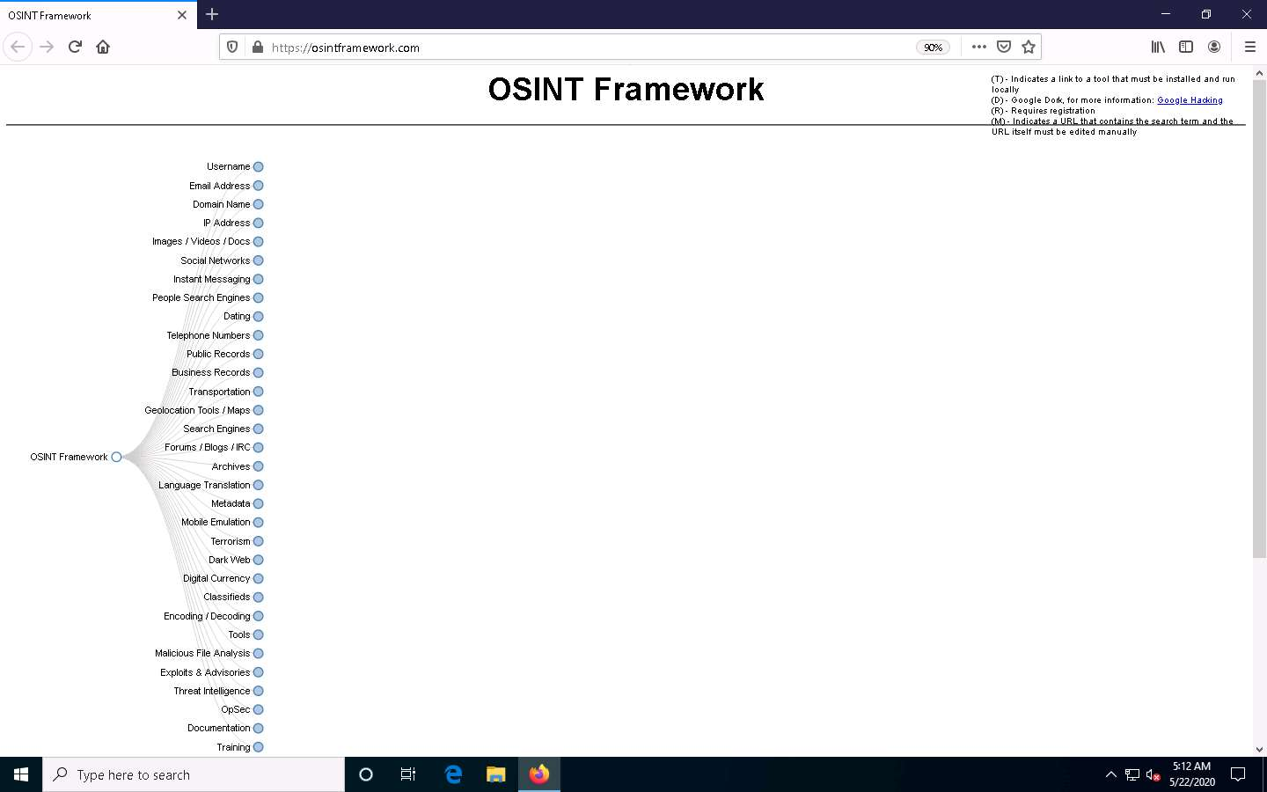

1. Clicking on any of the categories such as **Username**, **Email Address**, or **Domain Name** will make many useful resources appear on the screen in the form of a sub-tree.
2. Click the **Username** category and click to expand the **Username Search Engines** and **Specific Sites** sub-categories.
3. You can observe a list of OSINT tools filtered by sub-categories (**Username Search Engines** and **Specific Sites** sub-categories).

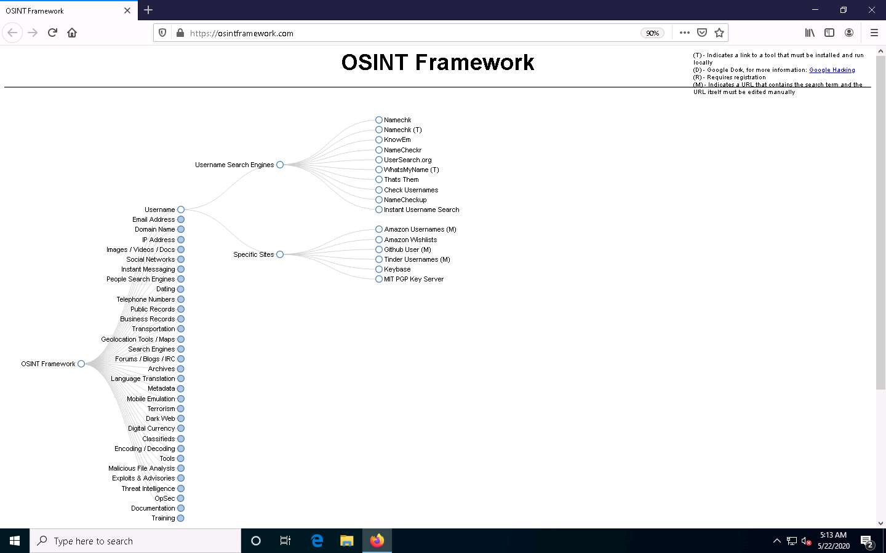

1. From the list of available tools under the **Username Search Engines** category, click on the **Namechk** tool to navigate to the **Namechk** website.

If a cookie notification appears at the lower section of the window, click **Got it!** and close the ads appearing on the screen.

1. The **Namechk** website appears, as shown in the screenshot.

Namechk is used to see if your desired username or vanity URL is still available at dozens of popular social networking and social bookmarking websites. You can also find the best username with Namechk.

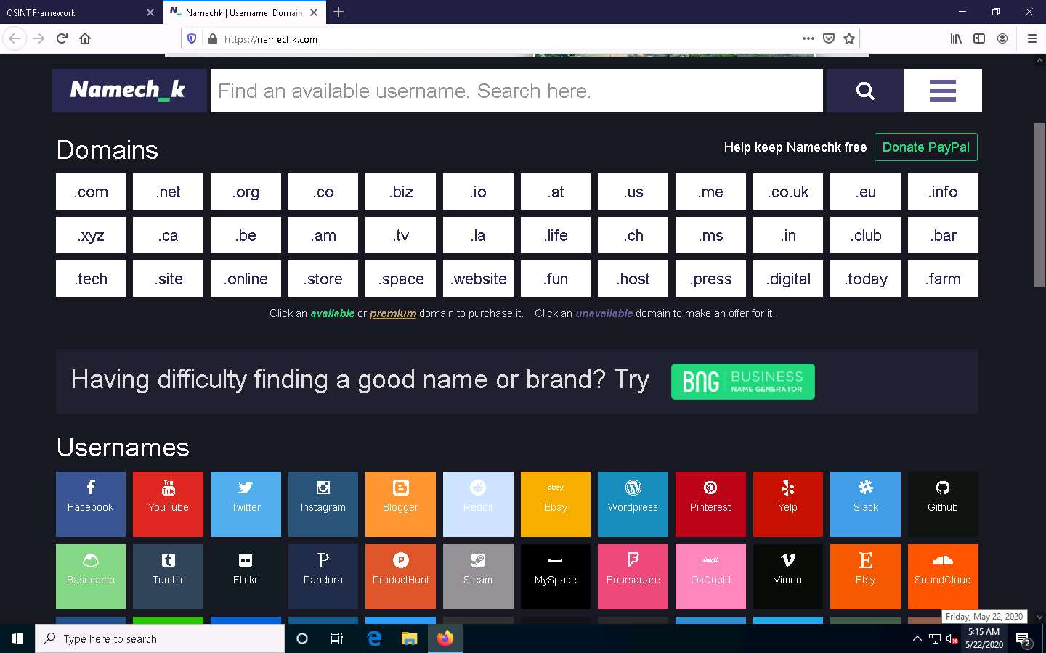

1. Close the current tab to navigate back to the OSINT Framework webpage.
2. Similarly, you can explore other tools from the list of mentioned tools under the **Username Search Engines** and **Specific Sites** sub-categories.
3. Now, click the **Domain Name** category, and its sub-categories appear. Click to expand the **Whois Records** sub-category.
4. A list of tools under the **Whois Records** sub-category appears; click the **Domain Dossier** tool.

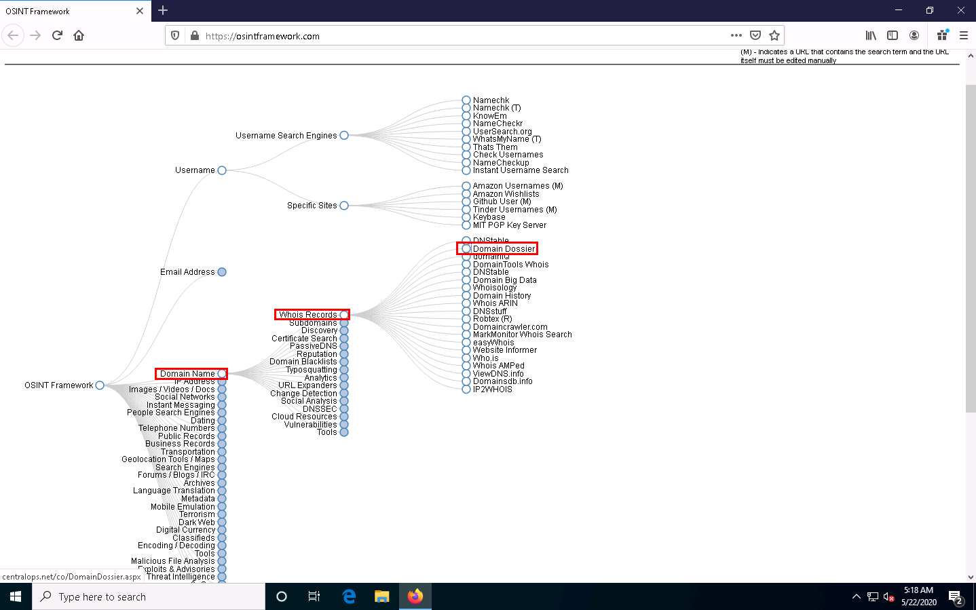

1. The **Domain Dossier** website appears, as shown in the screenshot.

The Domain Dossier tool generates reports from public records about domain names and IP addresses to help solve problems, investigate cybercrime, or just to better understand how things are set up.

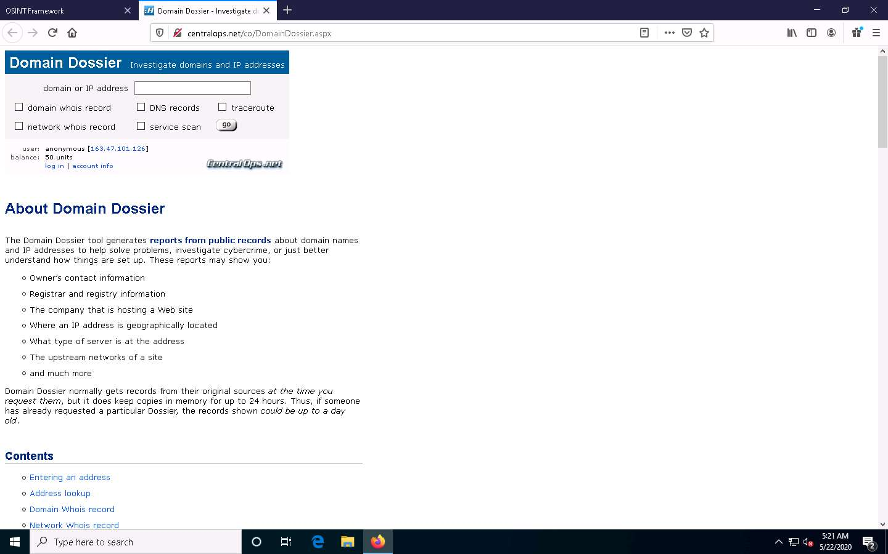

1. Close the current tab to navigate back to the **OSINT Framework** webpage.
2. Now, click the **Metadata** category and click the **FOCA** tool from a list of available tools.

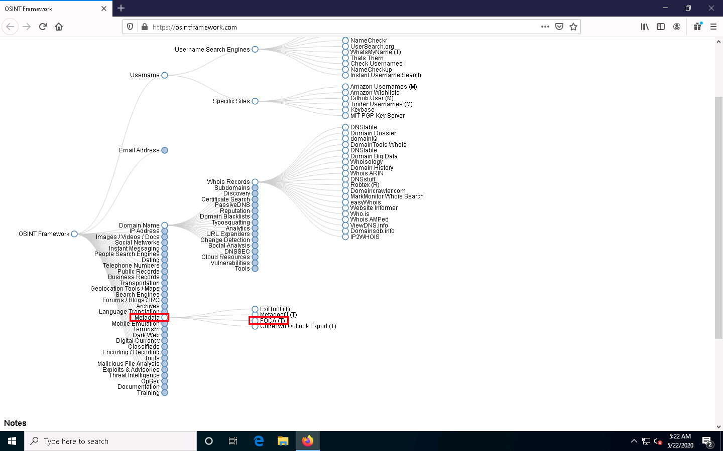

1. The **FOCA** website appears, displaying information about the tool along with its download link, as shown in the screenshot.

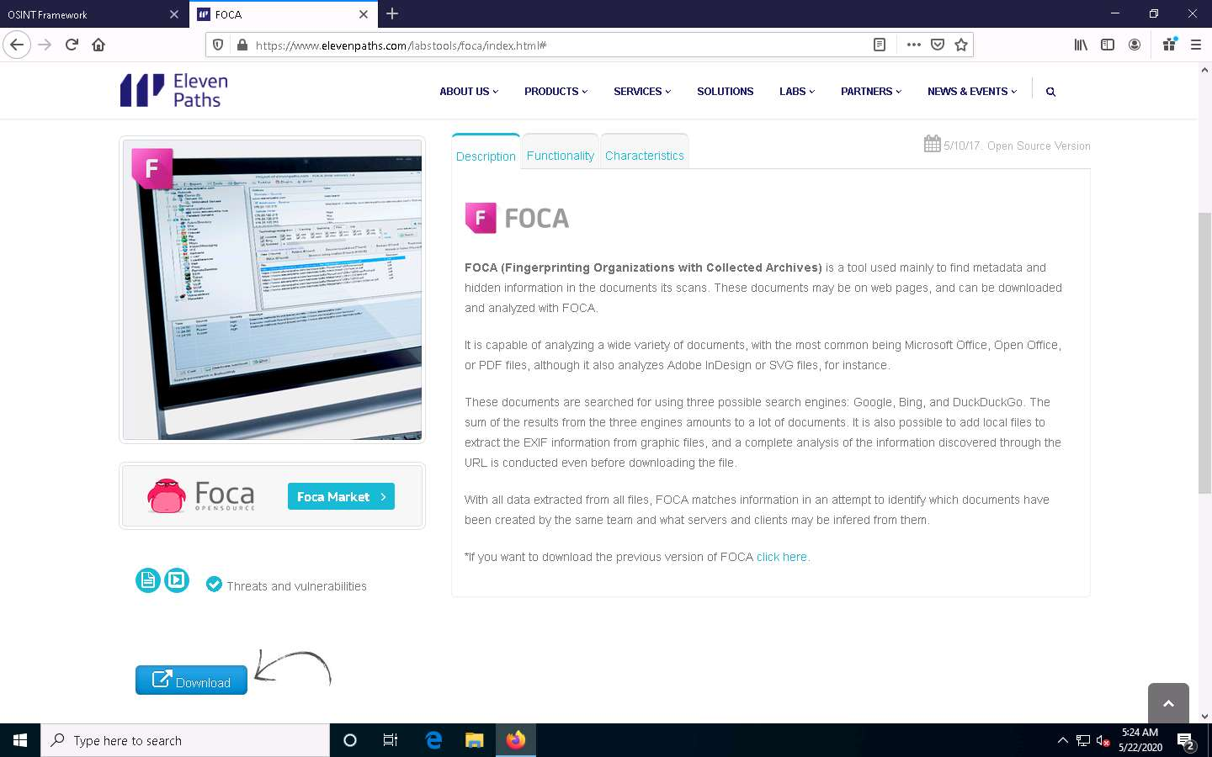

1. Similarly, you can explore other available categories such as **Email Address**, **IP Address**, **Social Networks**, **Instant Messaging**, etc. and the tools associated with each category. Using these tools, you can perform footprinting on the target organization.
2. This concludes the demonstration of performing footprinting using the OSINT Framework.
3. Close all open windows and document all the acquired information.